Toyota Prius Bluetooth
Phonebook Transfer for: Sony Ericsson T610

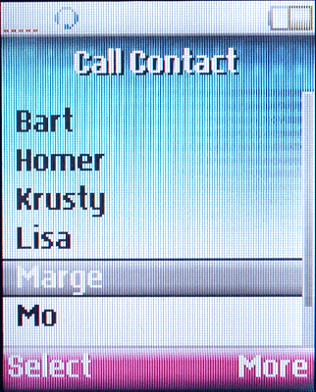 | To transfer (copy) the "Call Contact" list in the phone to the "Phone Book" in the Prius, do the following steps:
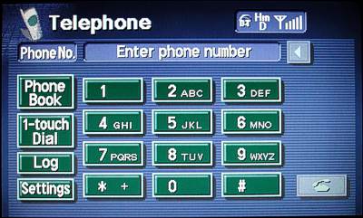 | Press "Settings"
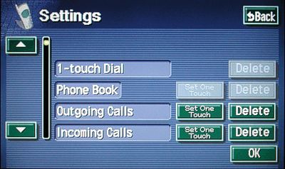 | Press the arrow on the left to scroll down.
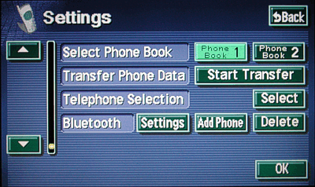 | Press "Start Transfer"
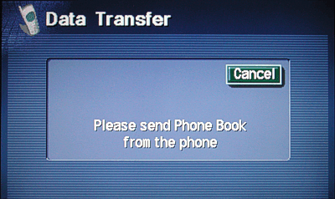 | This message should automatically appear.
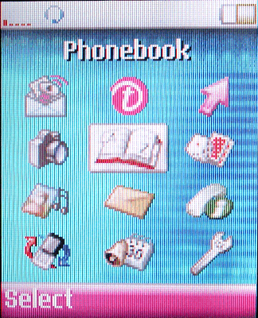 | Select "Phonebook"
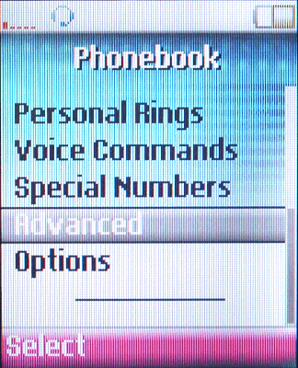 | Select "Advanced"
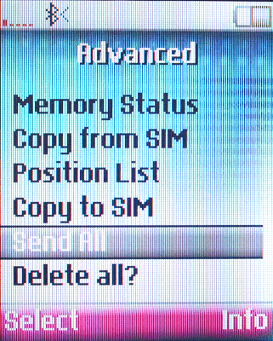 | Select "Send All"
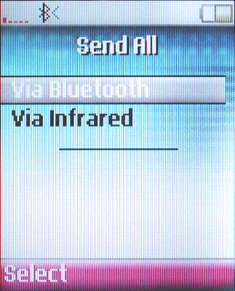 | Select "Via Bluetooth"
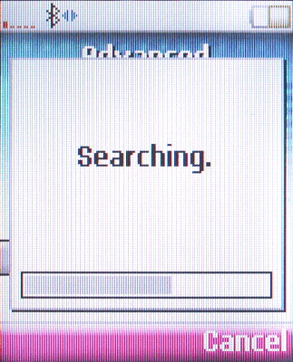 | Searching for the Prius system will occur.
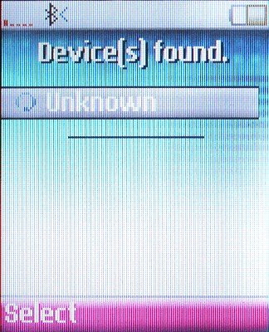 | Select "Unknown"
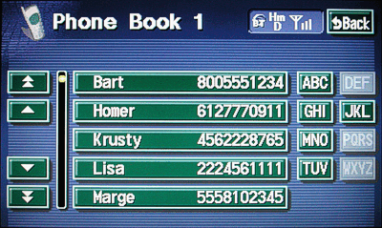 | When the transfer process is complete, the "Phone Book" on the Prius should show the same list as on the phone.

