Disclaimer:

All the information stated in this document was provided by Prius owners. None were affiliated with Toyota Motor Corporation, except as customers.

This document is not sanctioned by Toyota Motor Corporation or any of its affiliates.

The ideas, suggestions, and opinions offered in this document have not been endorsed by the manufacturer of those specific components or Toyota Motor Corporation.
Any harm or damage that may result from the application of or the following of any ideas, suggestions, or opinions contained in this document is the sole responsibility of the individual that applied or followed said ideas, suggestions or opinions.

The authors of this document hereby declare that they cannot and will not be held liable, in any fashion, for the content or the use of this document.
Prius Maintenance
Changing Oil

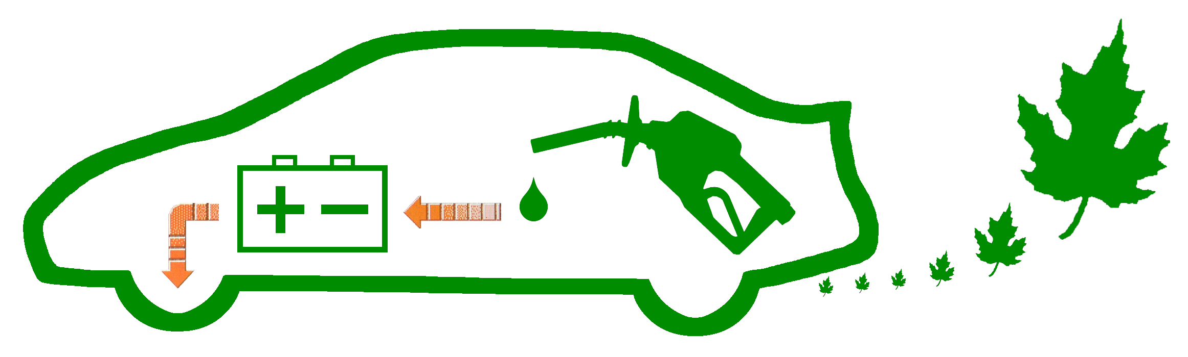

OVERFILL - This is an irritating problem a number of Prius owners have to deal with. Careless mechanics will sometimes pour too much oil into the engine. Beside the risk of damage from overfill, efficiency is reduced. Excess oil will cause MPG to drop.
Please dispose of the used oil & filters properly. Pour the oil into the emptied bottles afterward, then drop them off at a recycling center. If isn’t one near by, many repair shops will accept used oil. (There is sometimes a fee for disposal.) Used filters can often be disposed of at that same location.

SYNTHETIC - A simple way to better protect your engine from wear and increase efficiency a little bit is to switch from regular oil to synthetic. And by doing it yourself, rather than paying a mechanic, you’ll save some money and have greater confidence that it was done properly.

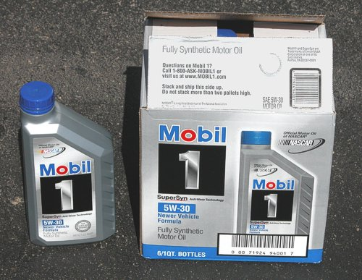 | 5W-30 Synthetic Oil
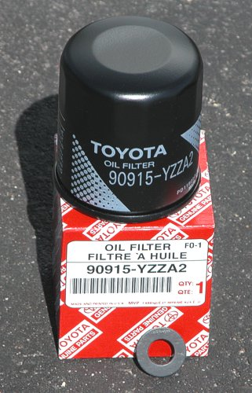 | Oil Filter Toyota Part: 90915-YZZF2  or: 90915-YZZA2  Plug Gasket Toyota Part: 90430-12028
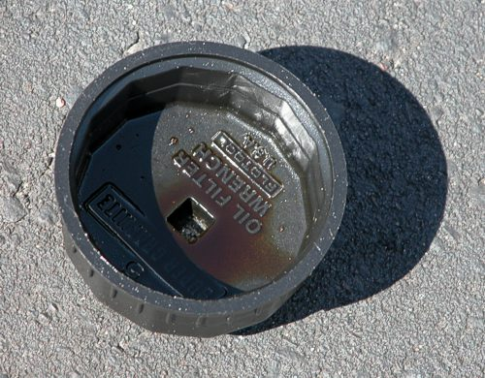 | Filter Wrench Checker Part: 32100-10605
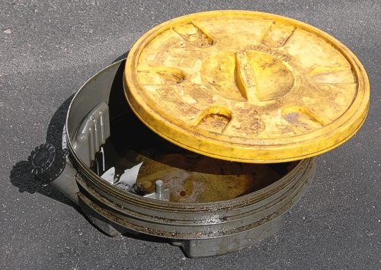 | Oil Basin with drain spout
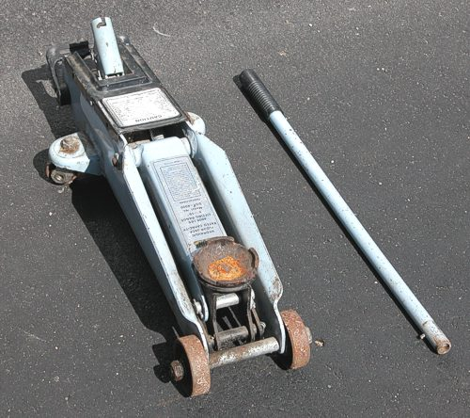 | Hydraulic Jack (2-Ton displayed)
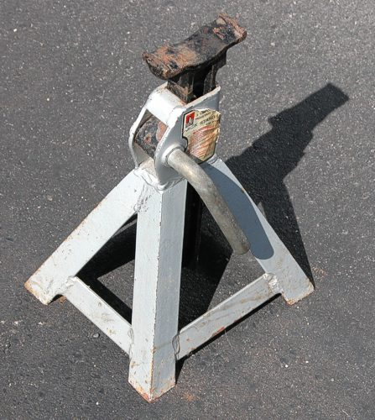 | Vehicle Stand (3-Ton displayed)
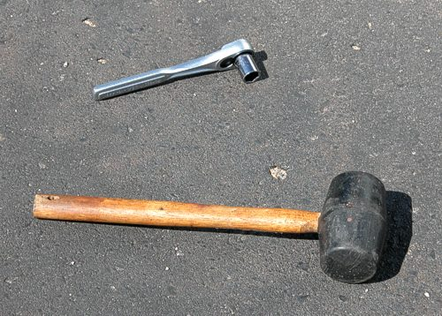 | Ratchet & 14mm Socket  Rubber Mallet
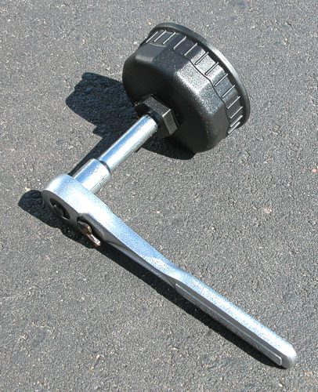 | 2.5 inch Ratchet Extension  (shown with the filter wrench & ratchet attached)
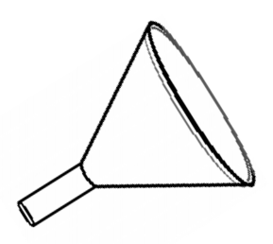 | Funnel  Any type will do, as long as it is absolutely clean. Using a disposal paper type, like the kind shown on page 11, works best.

AT YOUR OWN RISK - No liability is accepted for anything mentioned within this document; all actions are at your own risk. You are responsible for any damage caused by improper use of tools, including over-tightening of components. Proceed with care.

SEVERE INJURY - Lifting and working underneath a vehicle can be very dangerous. Inadequate support can cause the vehicle to fall on top of you, resulting in serious bodily harm or even death. Please be very cautious.

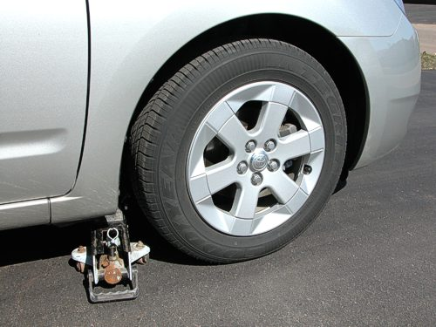  Lift location, before using the jack. | 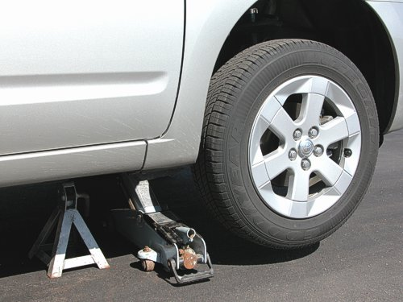  After lifting, with stand support.

Before lifting the vehicle you must find a level surface to do the work.

Once you drive the Prius there, engage the Parking Brake (shown below) by depressing the pedal all the way.

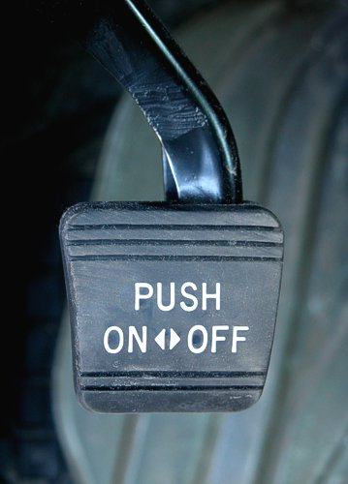

To assure the Prius doesn’t roll at all when you are lifting in or while working underneath, secure at least one of the back tires. Any large heavy object that is difficult to push will do, such as the 40lb. bag of rock salt shown below.

BOTH sides of the tire should be secured, unlike the example below (which was simplified due to difficult lighting).

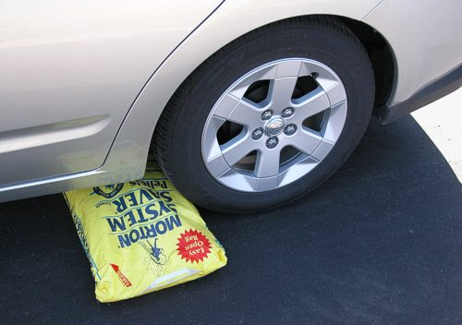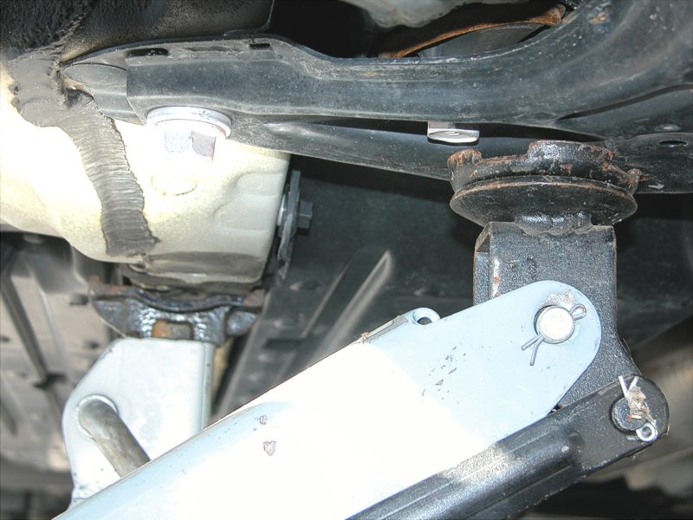

Carefully observe the placement of the jack grip. Make sure there is no possible way it could slip as the vehicle rises, which causes the jack to move forward. The placement is actually more important than all the grippers needing to make full contact.

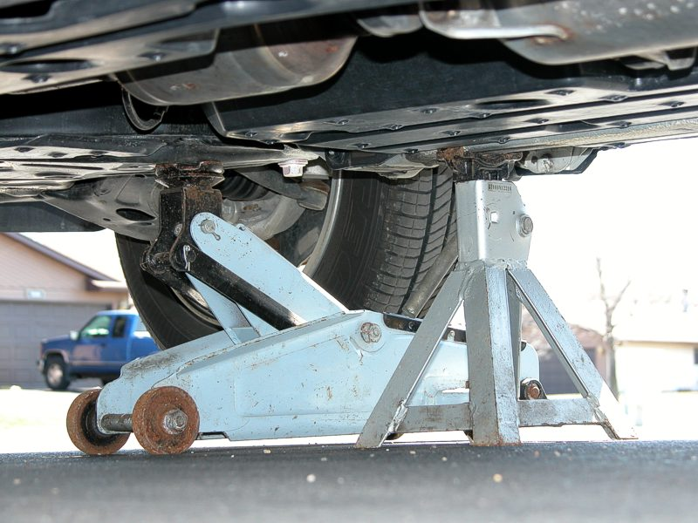

Notice how a grip edge for the jack is lined up to wrap around and hold part of the frame securely. That will help to make sure there is less of a chance for slipping.

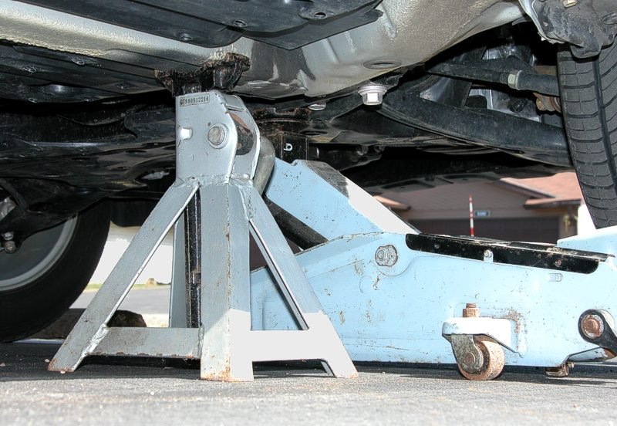

Make note of the stand placement. It is directly beneath the main frame for the length of the vehicle.

The stand is what will be providing primary support, not the jack. Hydraulic jacks sometimes slowly leak, causing the height of the vehicle to progressively decrease. So you shouldn’t ever trust the jack alone to hold up the vehicle for too long.

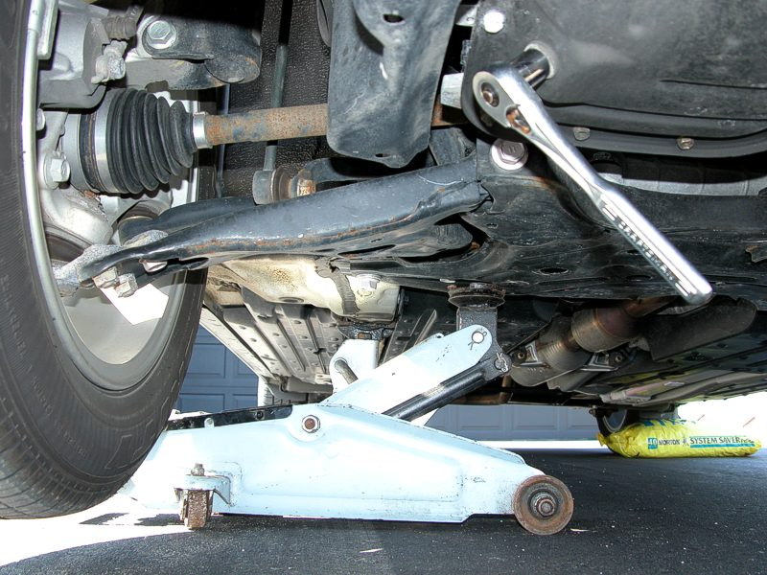

Reaching the oil pan is very convenient, since the engine is small & offset. This is an advantage traditional vehicles cannot offer. (Prius, gotta love it!)

Oil plug location is shown by the ratchet, which is contacted directly to it in the photo above.
Once you have carefully lifted & secured the vehicle, you may loosen the oil plug.

COUNTER-CLOCKWISE is the direction you must turn the plug to loosen it.

This is where the rubber mallet may be needed. If the plug is on so tight that you just plain can’t break it loose, it is ok to give the ratchet handle a few taps with the mallet. Just make sure you have a good grip; otherwise, you may strip (damage) the head of the plug.

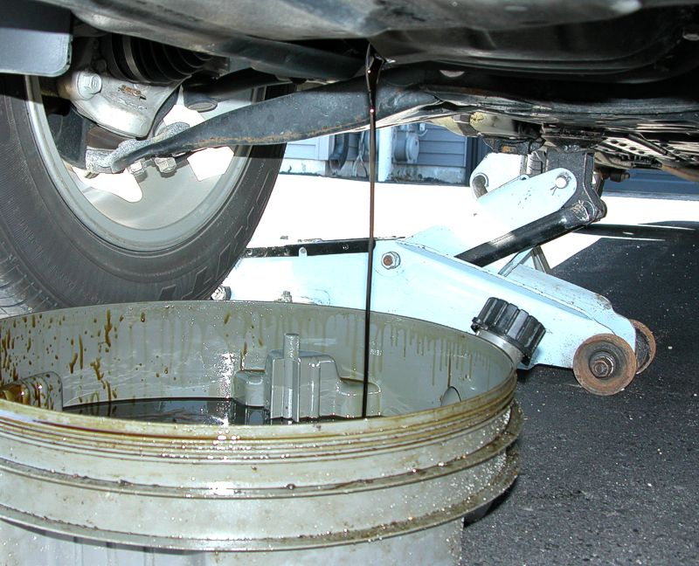

Be careful not to drop the plug once the oil begins to pour out. And make sure the basin is properly lined up to prevent spilling any oil, since it will stream out quickly causing some splashing. (Eye protection is recommended.)

Notice the indentation on this used gasket (commonly referred to as a “crush washer”) that caused by tightening.

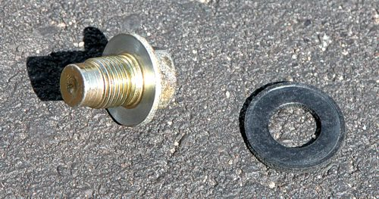

When the oil has finished draining, put the plug back in using a new gasket. Turn it in a CLOCKWISE direction.
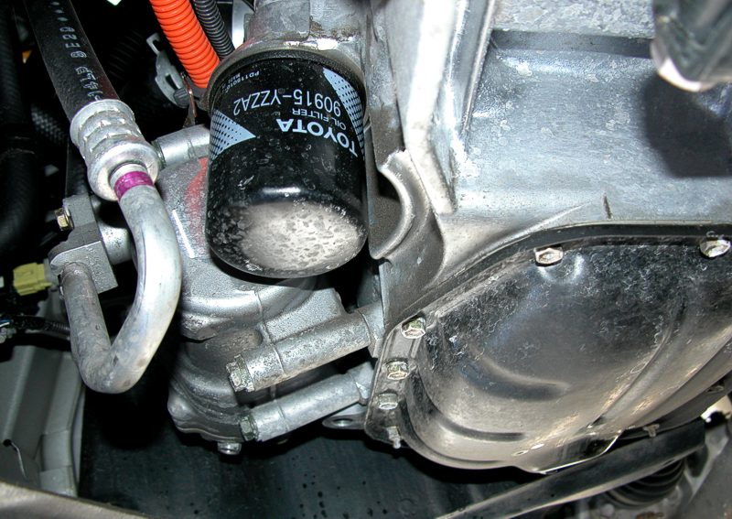

The oil filter is located next to the oil pan, closer to the front of the Prius.

COUNTER-CLOCKWISE is the direction you must turn the filter to loosen it. Use the ratchet, extension, and filter wrench, as shown on page 4.

Oil will very likely spill out of the filter when you remove it, be prepared for the mess.

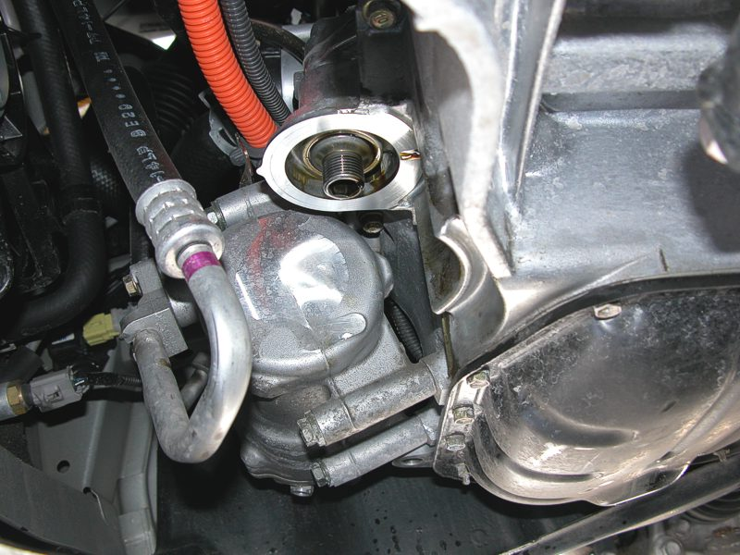

Wipe off all the oil from outer ring. (Note the drip on the surface still, shown intentionally for easier identification.)
The gasket (black rubber ring along the out top edge) of the filter should be moistened prior to installation. This will help ensure a tight, leak-proof seal is made. To do this, just dip your finger in the oil and wipe it along the gasket.

Before putting the new filter on, pour some oil into the center. It is best to have it partially filled when the engine startup process begins, rather than being completely dry.

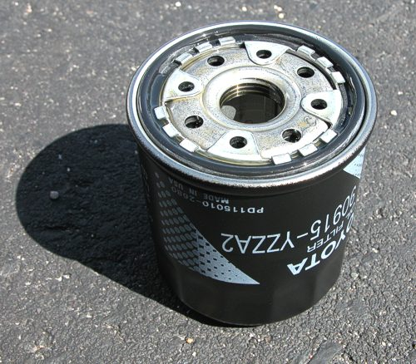

Don’t use a tool to tighten the oil filter unless absolutely necessary. A stronger person could easily overpower the gasket, causing it to be too tight. That could cause a leak. Of course, so could not tightening enough. So try the best you can with your hands only first.

Simply use your hand to twist it (clockwise) until you feel resistance. At that point, make note of the filter position to make sure you don’t over-tighten. Then, twist another three-quarters of a rotation.
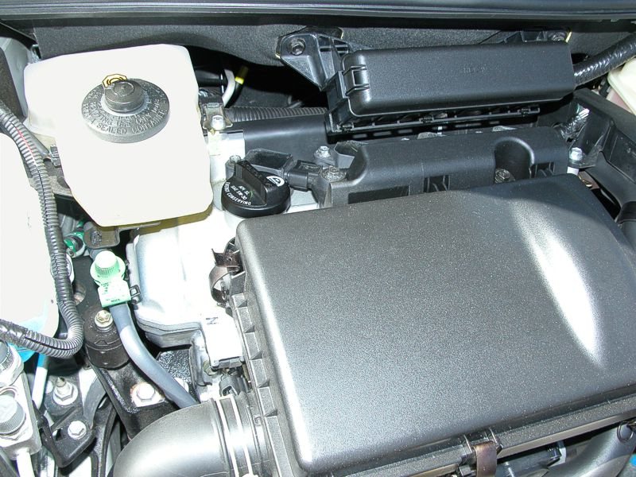

The black cap near the center of the above photo is where the new oil should be poured.

The funnel in the photo below was placed into the opening where the black cap was.

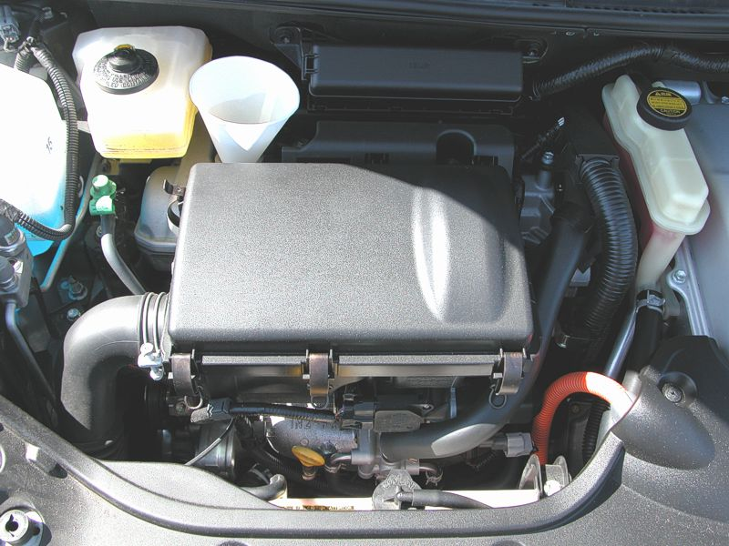

3.3 quarts of oil should be poured into the funnel, since is far too easy to overfill. Adding more later is simple. Removing excess afterward is very difficult, so being conservative is rather important.

That small, round, yellow handle in the bottom center of the photo above is the dipstick, which is for checking the oil level.
Pull out the dipstick. It may be difficult at first, so use care to avoid scraping a knuckle on your hand.

Wipe the dipstick dry using a clean paper towel.

Insert the cleaned dipstick back into the engine, pushing all the way until it clicks tight.

Remove the dipstick again, and quickly make note of the oil level.

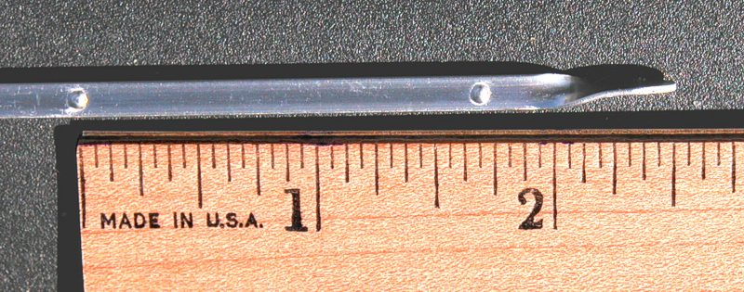

The ideal level is 1/4” (one-quarter inch) below the full mark.

That is between the D and the E on the photo above.

Check your work afterward. After the engine has be restarted and run for a few minutes, make sure there are not any leaks. If there are, you must fix them since there is a possibility that the component could later loosen completely and fall off. That would result in serious engine damage.

Once you have finished adding the oil and carefully removed the vehicle stand & jack, you will want to shut off the “MAINT REQD” indicator inside the Prius. Here’s how:

- With the power on, switch to the odometer/trip-meter to display "ODO".
- Power OFF (push the "Power" button).
- Power ON, while holding the button for "ODO".

- Wait for the reminder light to stop flashing, then release.

