
Plug-In Analysis

Introduction
Hybrids have already demonstrated a variety of different ways to utilize electricity provided by a battery for increased efficiency. Currently, the source of that electricity is from the vehicle itself, using an engine to power a generator. Aftermarket upgrades have shown that electricity can be used to boost efficiency even higher. The advantage of this is that electricity it gets from an external source can be generated by cleaner means than gasoline, such as renewable sources like solar & wind.
Prius is a FULL hybrid, which uses two electric-motors and a power-split-device to prevent energy waste associated with normal operation of a combustion engine. This resulting MPG is significantly higher than an equivalent sized vehicle using the same size engine. That efficiency gain can be boosted by increasing battery capacity and using a plug to recharge it.
Volt is an upcoming hybrid of a different design, it is the SERIES type. Rather than an engine working in combination with electric motors to provide thrust, the only purpose for the combustion of gasoline is to power a generator and supply heat. Propulsion itself comes directly from electricity. Much like FULL hybrids, the more electricity that’s available, the greater the resulting efficiency.

Efficiency Measure
Results vary dramatically, even when there isn’t a plug involved. Conditions such as speed & temperature have a profound effect on efficiency, making the determination of an expectation under just standardized situations a tremendous challenge. Real-World data differs so much among hybrid owners it has become a source of great frustration. They cannot predict what MPG their particular drive will deliver.
To complicate matters, operating efficiency of motors, engines, and batteries differ. So, even hybrids of the same type driven under identical conditions will yield different results. This makes any attempt to measure efficiency just a crude estimate, at best. No true standard approach may be available for many years. Still after decades, following genuine attempts to adjust, the EPA continues to struggle with this problem for traditional vehicles… making the likelihood of something soon for plug-in vehicles quite unrealistic.

MPG Estimates
Attempts to provide consumers with a general idea of what to expect from a hybrid vehicle offering the option to plug for recharging have only contributed to existing confusion, making the challenge even more difficult. How can the efficiency boost be portrayed in a manner that isn’t misleading?
A highly publicized attempt was the “230 MPG” campaign for Volt in August of 2009. That efficiency estimate was only for city driving though, which immediately resulted in questions about highway driving and other factors which could reduce overall MPG of a plug-in hybrid. Gas would be consumed, but when? How much electricity is consumed for passenger cooling & heating?
To get a basic understanding of the improvement a plug can provide, it is necessary to start with a basis of comparison. The following graphs illustrate 6 months of real-world data from a 2010 Prius owner living in Minnesota who drives 20,000 miles annually:
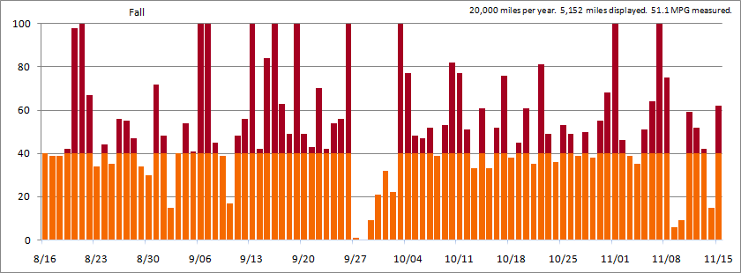
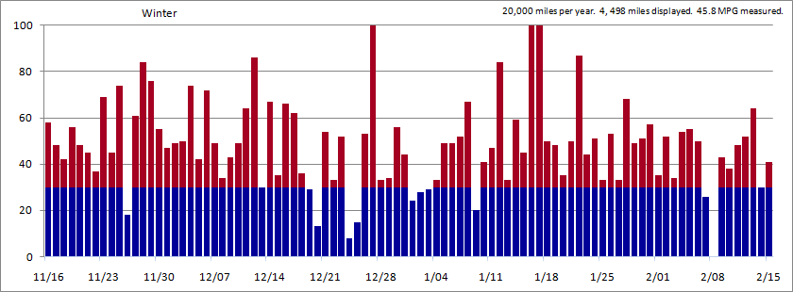
Notice the distance variation from day to day. An advertisement highlight for Volt is that the majority drive less 40 miles per day, which means any travel beyond that distance would not benefit from the electricity provided by a plug. And of course, that available capacity is reduced the A/C or Heater is required. In both graphs, distance exceeding the seasonal threshold is indicated by red.

Understanding Types
We know that FULL hybrids have a configuration where the engine & motor power can be combined for vehicle propulsion, using as much electricity as possible for maximum efficiency. We also know that SERIES hybrids only use a motor for propulsion, depending primarily on it and only using the engine when absolutely necessary. Those very different approaches can cause very different MPG results. But don’t forget, driving circumstances have a big influence too.
For a hybrid like Volt, it’s easy to see how the 40-mile electric-only estimate would split into the two power sources. In the most simplistic of terms, everything below 40 would be electric and the miles driven beyond 40 would be by gas with the engine. This, of course, assumes the vehicle is only recharged once daily at night. Also, Volt weighs 850 pounds more than Prius. That significantly heavier weight, a less efficient engine pumping cycle, and electricity conversion loss is what contributes to the 40 MPG estimate.
For a hybrid like Prius, it’s more complicated. Use of the engine can contribute to overall higher efficiency when the electric motor contributes thrust in a manner to allow combustion to be optimized. (That’s a fancy way of saying it prevents wasting gas.) Using electricity provided by a plug significantly boosts MPG, rather than attempting to eliminate gas consumption entirely.

Calculation Samples
Those 6 months of real-world data are divided into 2 graphs. The first depicts Fall driving, when the need for cooling & heating is modest. The first depicts Winter driving, when A/C for window defrosting and Heater for keeping passengers warm is required.
Li-Ion, like other rechargeable batteries, offers reduced capacity during the Winter. But unlike NiMH found in the current non-plug hybrids, Li-Ion must be warmed to above the freezing point to operate properly. If a plug-in hybrid is plugged in, the warming can be accomplished using that electricity. If not, the engine must be run to generate heat. For a FULL hybrid with a plug, running the engine while the battery-pack still has an ample supply of plug-provided electricity is part of normal operation, so there is minimal impact to the efficiency boost. For a SERIES hybrid, running the engine prior to reaching the depletion threshold causes a pronounced efficiency penalty.
When attempting to calculate the efficiency boost a plug could provide for a FULL hybrid, aftermarket conversion have demonstrated it’s just a matter of added a MPG boost value. Using the real-world average for the Fall driving of 51.1 MPG, a boost of 25 MPG would bring that to about 76 MPG. Over the collected 5,152 miles, that calculates to a consumption of 67.8 gallons. Winter will provide less MPG boost due to warm-up and heater use. But don’t forget that that FULL hybrid only uses electricity as a supplement for heat, that most of it is from the when the engine runs. If that works out 18.75 MPG, based on the real-world average of 45.8 MPG and a 25% reduction of capacity, it would calculate to boost it up to about 64.5 MPG. Over the collected 4,498 miles, the result would be consumption of 69.7 gallons.
When attempting to calculate the amount of gas consumed by a SERIES hybrid, you must exclude the miles driven before reaching the depletion threshold and add the fuel used during warm-up. For Fall, depletion is about 40 miles and warm-up won’t be needed much. If engine (generator) efficiency during charge-sustaining mode (what happens after depletion) is 40 MPG, the 1,830 miles remaining would consume about 45.8 gallons. For Winter, depletion is about 30 miles from a 25% reduction of capacity. Warm-up is also required routinely. Assuming a lower engine efficiency of 38 MPG due to winter-formula gas, the 1,858 miles remaining would consume about 48.9 gallons. Also taking into account that warm-up, based on the standard idle rate of 0.5 gallons-per-hour and an efficiency drive of 1.0 gallons-per-hour, we can approximate that 5 additional gallons will be consumed over the entire Winter. That brings the total to 53.9 gallons.
gallons consumed @ 20,000 annual | Fall | Winter | Spring | Summer | Total | Overall MPG
30fs /28w MPG non-hybrid | 171.7 | 160.6 | 153.5 |  | 485.8 | 29.3
FULL hybrid | 100.8 | 98.2 | 93.6 |  | 292.6 | 48.7
FULL hybrid with plug | 67.8 | 69.7 | 62.1 |  | 199.6 | 71.4
SERIES hybrid | 45.8 | 53.9 | 35.2 |  | 134.9 | 105.7

Annual Miles
There is greater benefit from using electricity supplied by a plug if you drive less; this is simply a factor of the battery-capacity available. The 40-mile capacity advertised for Volt is derived in part by the basic equation of divided the typical annual driving distance of 15,000 miles by 365 days. That also takes into account a few extended highway trips per year, where a plug won’t be available for the duration, as well as there being a number of days where very few or no miles are driven.
Using that same real-world data collected, reducing the 20,000 annual miles to 15,000 can be done by of subtracting 25% from each daily total. It reduces charge-sustaining mode operation for the SERIES hybrid to 872.5 miles in Fall and 864 miles in Winter.
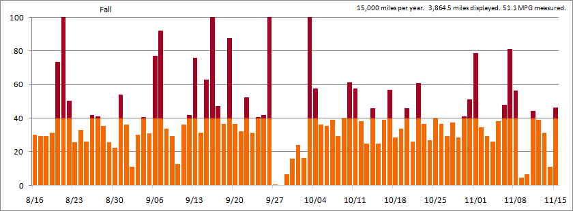
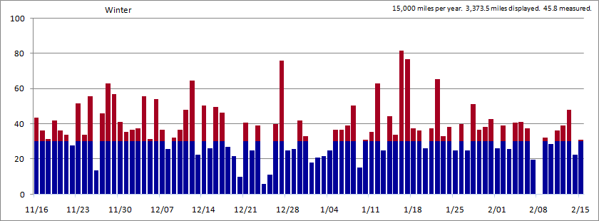
Knowing the available capacity is very important, since the distance driven between each overnight plug to recharge clearly makes big difference. Notice how it affects the amount of gallons consumed.
gallons consumed @ 15,000 annual | Fall | Winter | Spring | Summer | Total | Overall MPG
30fs/28w MPG non-hybrid | 128.8 | 120.5 | 115.1 |  | 364.4 | 29.3
FULL hybrid | 75.6 | 73.7 | 70.2 |  | 219.5 | 48.7
FULL hybrid with plug | 50.8 | 52.3 | 46.5 |  | 149.6 | 71.5
SERIES hybrid | 21.8 | 27.7 | 14.0 |  | 63.5 | 168.7

Vehicle Cost
A quick glance at the overall MPG is all it takes to realize that estimates tend to reflect favorable driving conditions, making an effort to portray plug-in hybrids without being misleading quite a challenge. Using real-world data as a basis for calculations helps to avoid some of the problems associated with estimates; however, it still doesn’t reflect the entire ownership experience. For that, you must also include how much the vehicle itself costs.
Some FULL hybrids substitute a traditional transmission with a power-split-device and motors. That helps to reduce cost. Using a modest sized battery-pack helps keep the final price competitive with non-hybrid vehicles. Upgrading to a battery-pack that offers both greater energy density and significantly higher capacity is expensive, but that is what’s needed to take advantage of electricity supplied by a plug. With the example of the upcoming plug-in Prius, that Li-Ion upgrade offers 5.2 kWh of capacity with 3.56 kWh of usable power. (The unused portion serves as both a buffer for emergencies and a protective measure to ensure power throughout the entire lifetime of that battery-pack.)
With the example of Volt as a SERIES hybrid, it doesn’t have a transmission substitute (though it may offer a reduction gear similar to something like overdrive). Instead, it has a regular engine which serves as a generator and a very large electric motor for propulsion. Its efficiency comes from heavy reliance on the battery-pack. As a result of this configuration, that battery-pack is very large. Using Li-Ion, it offers 16 kWh of capacity with 11 kWh of usable power.
The expense of Li-Ion is a major factor holding back electric-only vehicles. That’s what contributes to the benefit of hybrids. They don’t require as much capacity. The plug-in variety increases costs though. Notice how the capacity of Volt is over triple that of the plug-in Prius. That’s a very expensive difference. For perspective, the electric Cooper Mini offers a 35 kWh capacity battery-pack (28 kWh usable) and the electric Nissan Leaf offers a 24 kWh capacity (19.2 kWh usable). Both are considered just short-range electric-only vehicles, since range is roughly 100 miles in ideal conditions. Both are extremely expensive.

Other Costs
Since hybrids have combustion engines, they’ll still need routine maintenance. Fluids & Filters need periodic replacing. The plug-in variety will likely measure those intervals based on time rather than distance. Brushless electric motors don’t ever need maintenance other than coolant replacement.
Extended drives for the occasional long-distance trip will primarily rely upon gas as a power source, since electricity from a plug most likely will not be realistic. This type of driving is more advantageous for FULL hybrids, since they don’t have to convert mechanical energy into electricity then back to mechanical as a SERIES hybrid does. Avoiding that additional conversion step is more efficient.
And of course, don’t forget about the cost of the electricity supplied by the plug.

Summary
One size does not fit all. Only being offered a single configuration means that if your driving need doesn’t closely match the distance intention between recharging, the benefit of the plug will not be met. It’s easy to see how efficiency of Volt drops off significantly if you drive more than 15,000 miles per year. It’s also easy to see how a 40-mile range is overkill if your daily commute is a very short distance. Why be required to pay for 16 kWh of capacity when you don’t need that much? For that matter, why be required to pay for a plug if you will not see much of a gain from having it? Additionally, keep in mind that not all electricity is equal. Some comes from clean & renewable sources. Others are quite harmful to the environment.
The market is quite diverse. Different consumers have different needs. The FULL hybrids have already demonstrated that a wide variety of configurations can be offered, along with the choice of a plug and battery-pack capacity. The SERIES hybrid will initially only be offered with a plug and with a single capacity. For those whose needs fit well, they may be able to take advantage of the opportunity. For those whose needs do not, what will they purchase?

Data
The real-world data used to create the graphs and calculate the gallons consumed is available from these 2007-format spreadsheets… http://john1701a.com/prius/spreadsheets/Prius-2010_MPG_Spreadsheet_Year-1.xlsx
http://john1701a.com/prius/spreadsheets/Prius-2010_MPG_Spreadsheet_Year-2.xlsx
Note the worksheets indicated by tabs in the lower-left corner.

Update: Spring
The real-world data collecting continued. There is another season (3-month span) to add to the calculations & observations. The charts in prior pages have been updated to now include this Spring data. After Summer data collection is complete, the entire document will be reassembled to provide an annual summary.
4,605 miles were driven. 3,245 of them fell under the 40-mile threshold with 1,408 exceeding it. That brings the 9-month total distance to 14,255 miles.
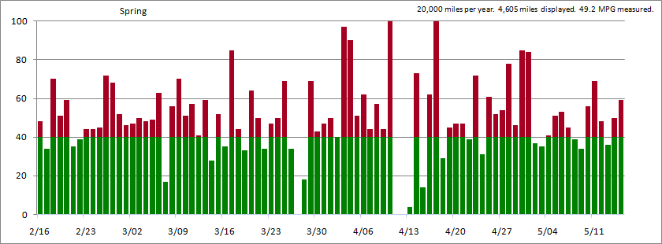
This is what that same data looks like when reducing it by 25 percent, to represent an annual driving distance of 15,000 miles rather than 20,000. Notice how it reduces the miles exceeding the 40-mile threshold to 559. This clearly illustrates why a vehicle like Volt is intended for a consumer who drive less than 12,000 miles annually. Driving further will require much more use of the gas engine.
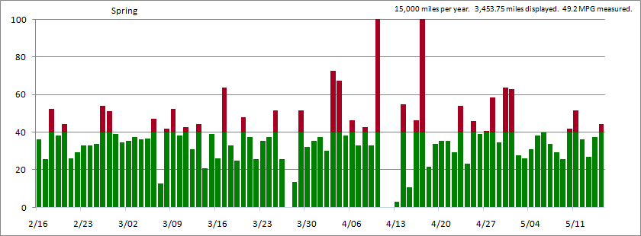

Update: Summer
Patience…
