Power - Split - Device (details)

This device, usually referred as the “PSD”, is the core of the full hybrid system in Prius. It is how the gasoline engine and two electric motors are connected. And because all of the components are permanently engaged, power is transferred like a common differential rather than a traditional automatic transmission... providing remarkably smooth operation and rapid responsiveness.

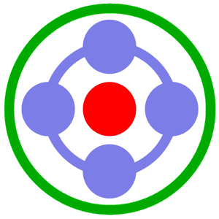 | PSD (all power components) | 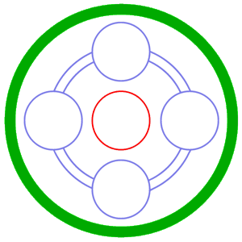 | 50 kW Electric Motor/Generator  called: “MG2”
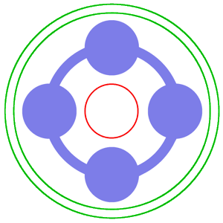 | 1.5 liter Gasoline Engine | 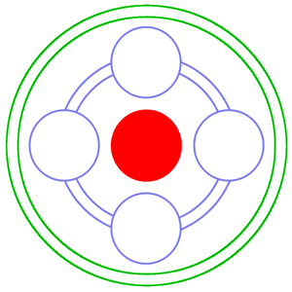 | 10 kW Electric Motor/Generator  called: “MG1”

Normal Connection (Side)  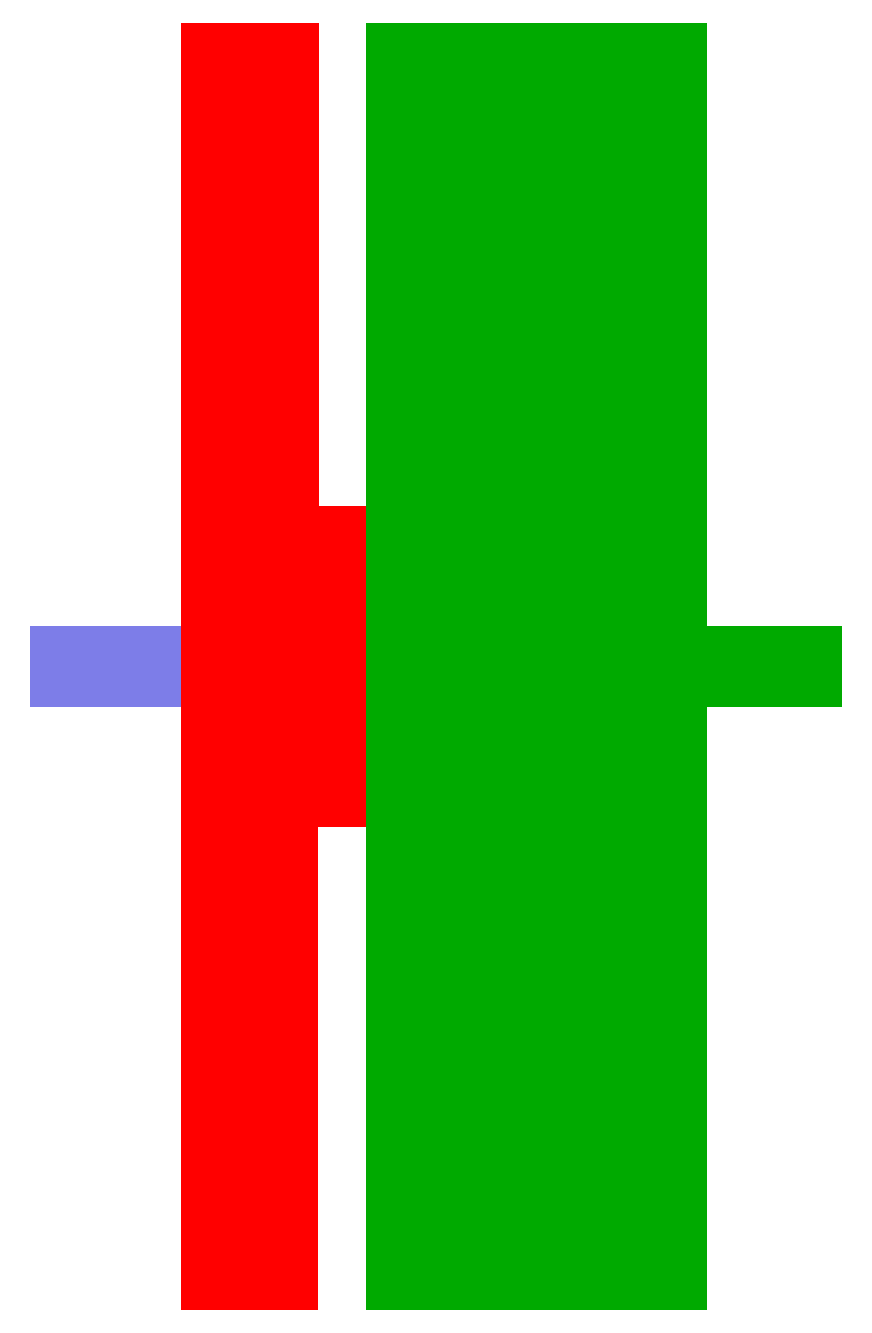 | Separated View (Side) | Normal Connection (Front)  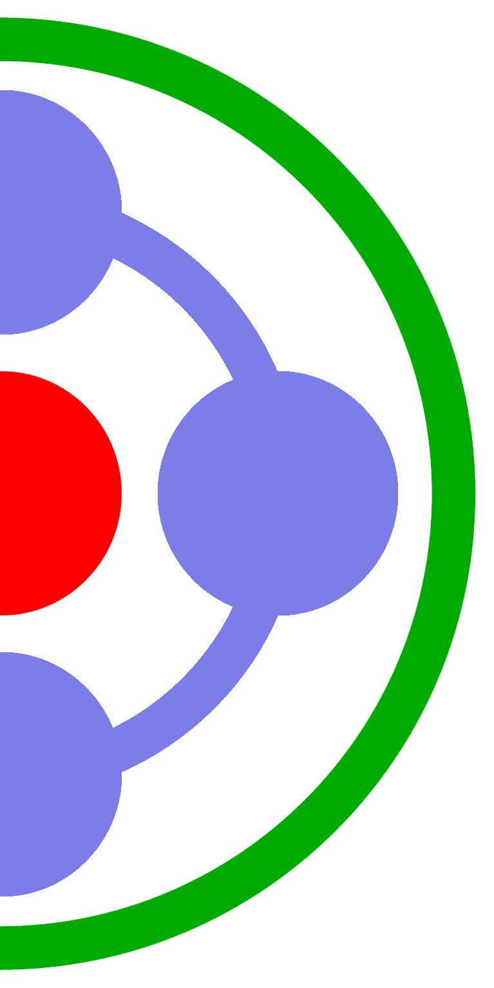

 | 201.6-Volt Battery-Pack |  | 50 kW Electric Motor/Generator  called: “MG2”
 | 1.5 liter Gasoline Engine |  | 10 kW Electric Motor/Generator  called: “MG1”

Though initially difficult to envision in motion and perhaps the belief of high complexity, you’ll eventually discover the PSD can be best described as “elegantly simple”.

To begin to understand what the heck it is you are looking at on illustrations within this document, you must first recognize the PSD’s purpose. As stated from the name “Power-Split-Device”, you can deduce that power is being split somehow. More accurately, it is thrust which is ultimately sent to the tires to propel the hybrid vehicle. This power can be supplied by three different sources: a gasoline engine and 2 electric motors. And in many cases, the power is not only split it is actually combined too. This depends on what is needed at each specific moment, which hints at the other ability of the PSD: being able to quickly alter operation. Electricity and spinning parts make this an easy process.

Looking at the normal connection and separated view illustrations on the previous page, notice how the three power sources within are inside of each other. One has a shaft that pokes through the center of the one in the center and the other encompasses the two. These are all different type of “power carriers”. Each has angled interlocking teeth, creating a permanent bond among the carrier it is in contact with. That means when one rotates, the other will always rotate too. This is the fundamental method of how power is transferred. But to keep those illustrations easier to understand, the teeth and physical connection they create are not displayed.

When the PSD operates, it will split and/or combine power to achieve the greatest efficiency. All thrust sent to the wheels for vehicle motion is directed to the outer most connection (that biggest ring). It is the large electric motor, which sometimes provides power, sometimes captures power, and sometimes just spins without any electricity flowing in either direction. The point is that several functions are possible. They can be switched within just a fraction of a second too, which is how even the smallest of efficiency gains are achieved. The PSD can take advantage of opportunities that other types of hybrids utilizing Manual, Automatic, or Cone & Belt type CVT transmissions cannot. The engine is middle device, nestled between the connections for the two electric motors. It provides, captures, and just spins as well. Believe it or not, that center device (the small motor) functions the very same way. Now do you understand why there is a common misconception that the PSD is extremely complex? All those operational combinations give that impression; but with only those power components permanently engaged and no gears to ever shift, it is a surprisingly minimal design.
Stopped

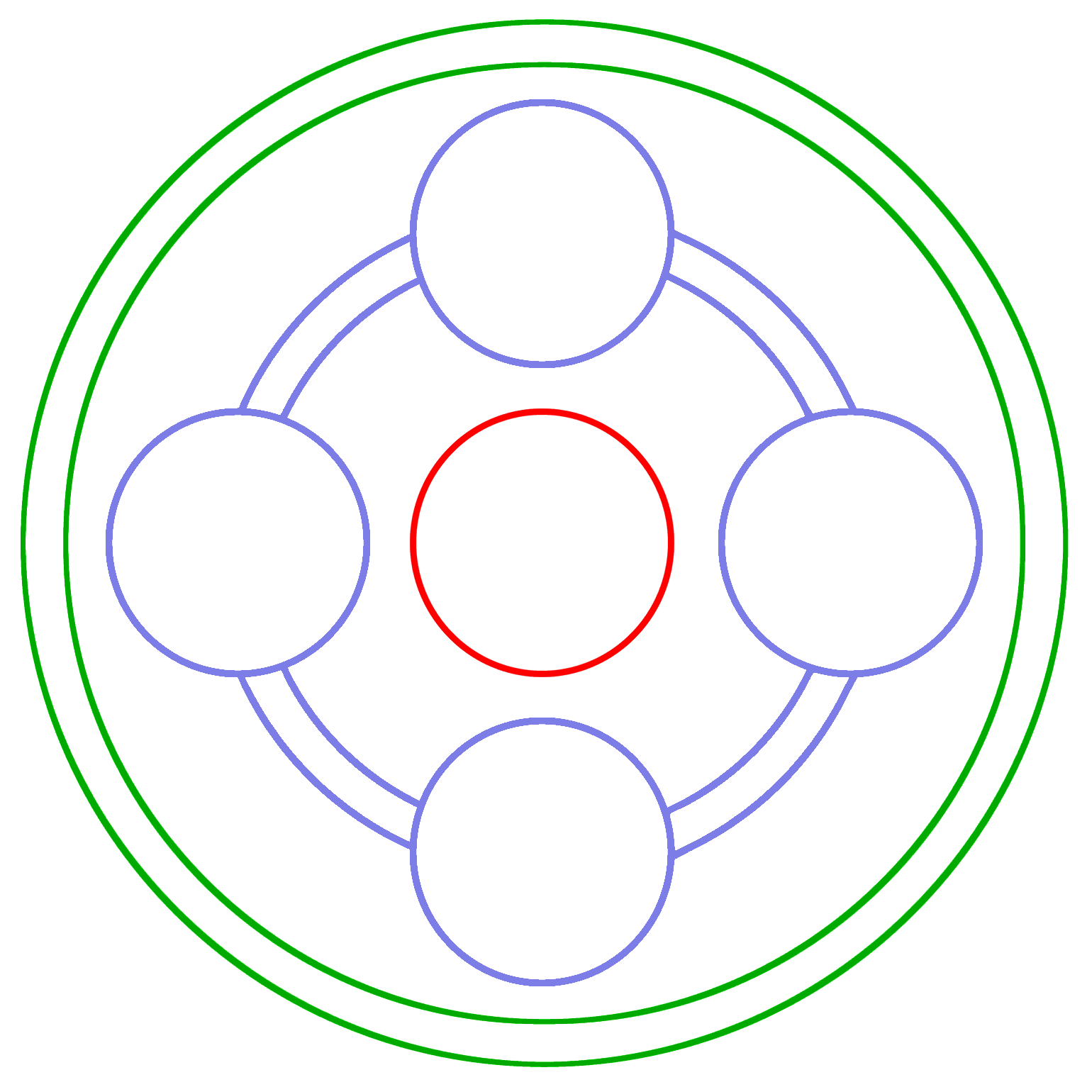

That illustration above is the PSD at rest. There are no components are moving, as depicted by the outlined (empty) items displayed.

When the “full” hybrid vehicle, like Prius, comes to a stop at a red light, this is usually what happens… since there is no need for the gas engine or either electric motor to do anything.

No movement within the PSD will resume until either the light turns green and you press the foot pedal to move forward or more heat is needed for the heater. (Because the A/C system in Prius is electric, the PSD will usually remain at rest even while waiting at a stoplight.)
Startup

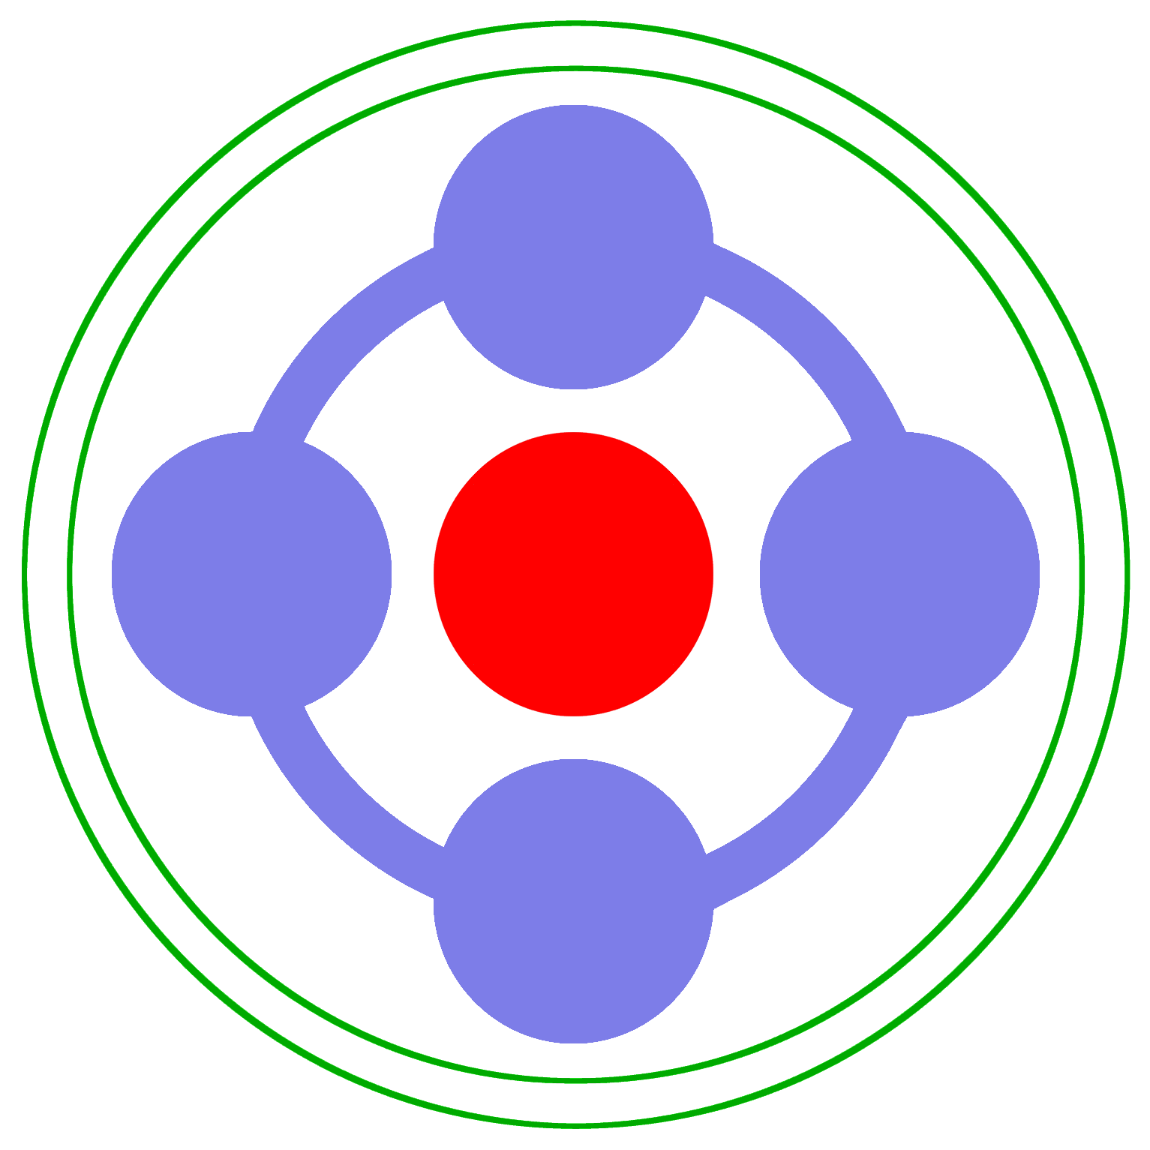

Shortly after pressing the power button to activate the hybrid system or the foot pedal to resume using it, this sequence to get the engine running again will occur.

The component depicted in the very center is the small motor, also referred to as “MG1”, will begin rotating in a clockwise manner. That will cause those 4 round components making direct contact with it to all begin rotating in a counter-clockwise manner. As the speed of increases, the resulting torque will force the entire assembly holding those 4 components to begin to revolve. That is the engine and the revolution within the PSD is also a revolution of the crankshaft, which is what allows the engine to start.

Also, note that those 4 rotating components are also in direct contact with the outer ring; however, none of the movement is transferred to it. Instead, the rotation of each just causes them to roll around it. Therefore, the wheels of the vehicle will not move. But if the wheels are already in motion, the startup process occurs by the same method anyway. The only difference is that less power is needed by the small motor to create enough resistance to cause the engine revolutions to begin.
Stealth

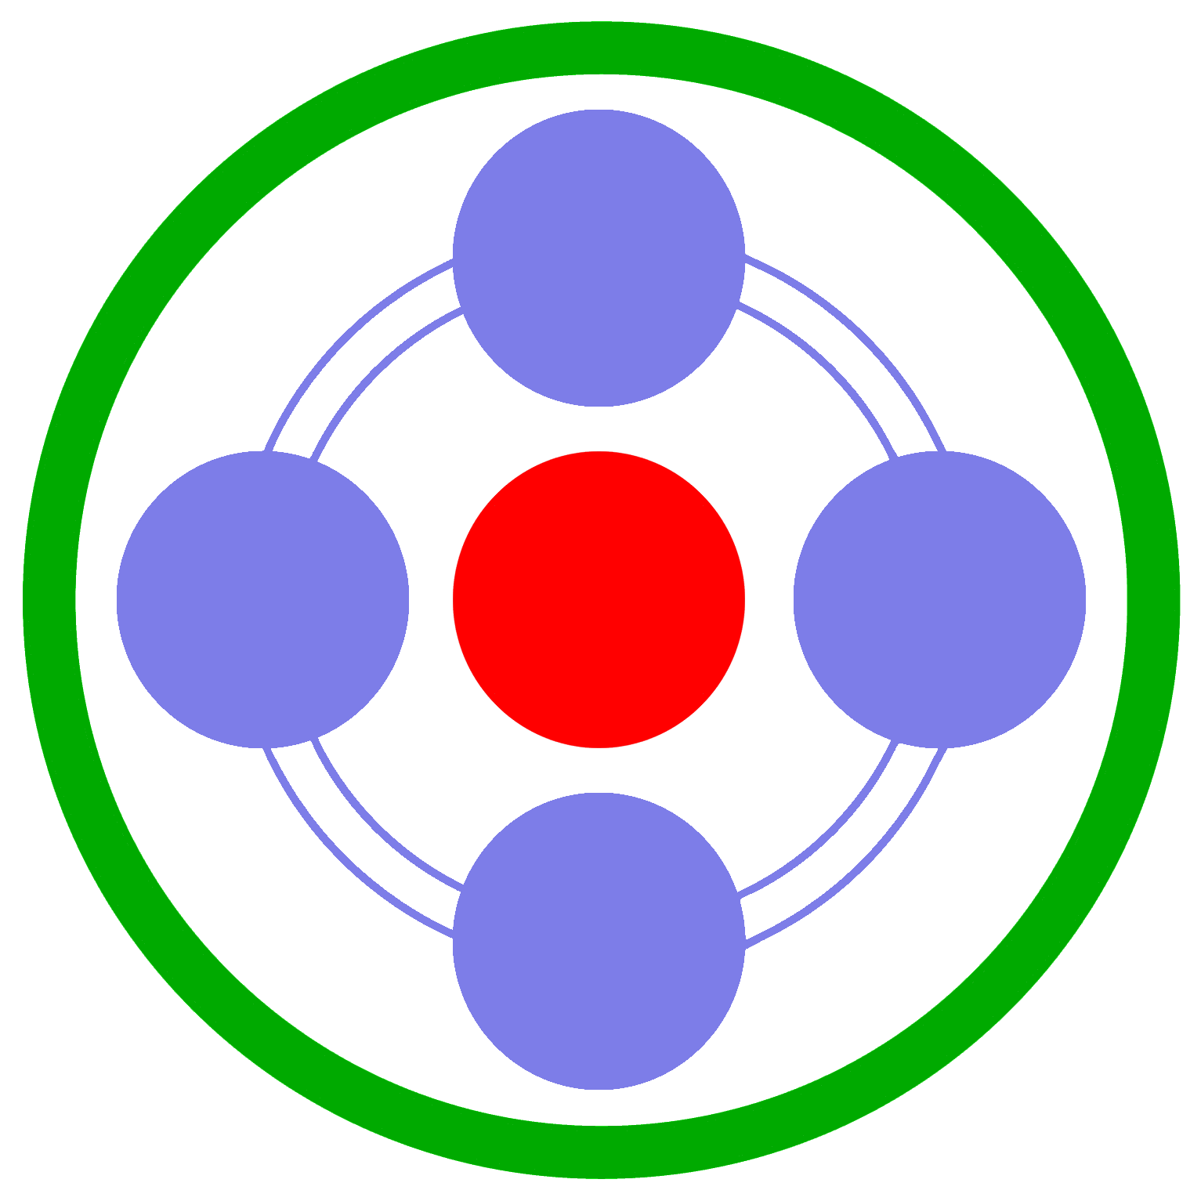

Even though this may appear to be like “Startup”, it is actually entirely different. Rather than the power coming from the center, it is coming from the outer ring. That is the larger motor, also referred to as “MG2”, which is how all power within the PSD is ultimately transferred to the wheels of the vehicle.

Electricity is sent to MG2 from the battery-pack to cause the outer ring to move. The resulting motion causes the 4 components of the engine connection to begin rotating. If MG1 in the center were prevented from moving (using electricity to hold it in place), engine revolving would occur. But instead, it rotates freely.

This method of powering the vehicle is completely silent, hence the term “Stealth”.
Accelerating

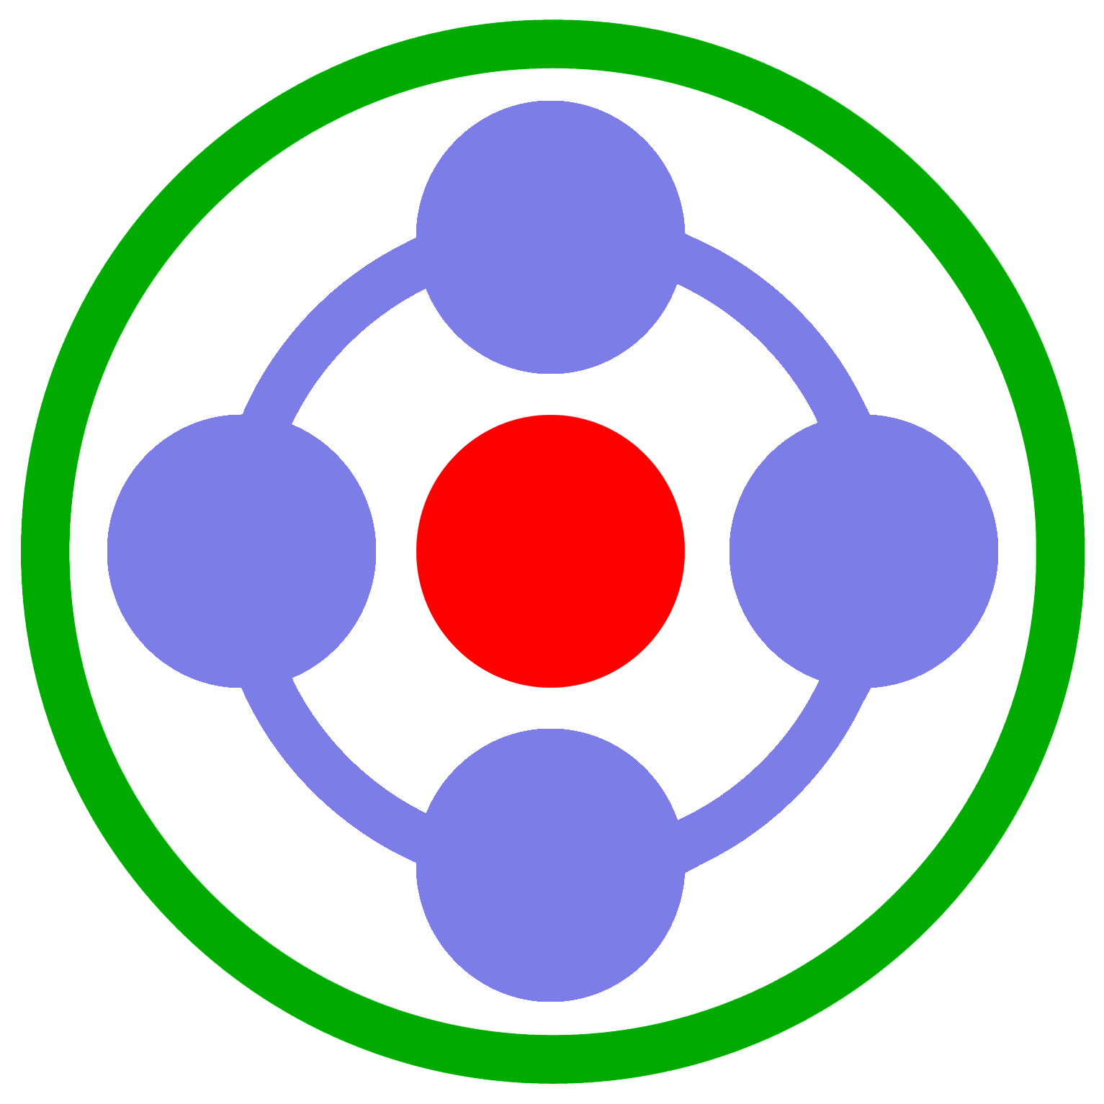

Notice how all components are active. That is what occurs when the vehicle is quickly accelerating.

Both the large motor and the engine are providing a generous amount of thrust for the wheels. The small motor is consequently rotating by this motion. As a result, that device in the center turns into a generator. It creates electricity, which in turn is immediately consumed by the large motor.

This motor-to-generator switch is a significant benefit to the life of the battery-pack, by eliminating the need to draw electricity from it. The ability to create that electricity on-the-fly is something that only the “full” type of hybrid can delivers. The “assist” type cannot, since it only has a system with one motor/generator.
Cruising

This mode is similar to “Accelerating”. But since less power is needed. The engine RPM will slow down enough to cause the power-carriers for the engine to actually spin in the opposite direction. This will continue until dropping below 42 MPH, which then causes the engine to stop and the mode to switch to “Coasting”.

The slower motion of the PSD actually causes that component in the center, MG1, to rotate opposite to the direction it normally does. The reason is simply that resistance is different while cruising, since less power is needed to maintain a constant speed while on the highway.
Reverse

This is an intriguing operational motion of the PSD.

With the engine off, the small motor will rotate to make its power-carriers rotate. That results in the large motor rotating, but in a backward direction.

It makes sense that reverse is achieved that way, until you actually observe how Prius reacts. The engine will sometimes start while you are driving backward. Yet when that revolution of the engine components within the PSD begins, the reverse mode continues anyway. The small motor simply rotates faster to compensate for the internal speed change, preventing the vehicle speed from changing.

It’s a simple, yet remarkably elegant, design that is able to provide a wide variety of ability with only a small number of permanently engage components.
Reverse with Engine Running

At some point while in “Reverse” driving backward, the engine may start to run. When that happens, it causes an internal spinning of the PSD that is actually counterproductive for producing power for the wheels. But since running the engine generates both heat and electricity, it is an acceptable thing to happen.

The existence of this mode is rather remarkable, since it completely eliminates the need for a reverse gear which all other vehicle types require. Full vehicle operation can continue as normal, regardless of which direction you need to drive.
Coasting

When no power is needed from the engine or either of the motors, this is what happens when the speed is slower than 42 MPH. (Faster is “Cruising”.)

The engine will stop entirely; however, rotation of its components (also known as “power-carriers”) will continue. The revolution will not. This allows both motors to freely move. It is the hybrid equivalent to the “neutral” in traditional vehicles.

Have you noticed how the terms “rotation” and “revolution” are used? Those “power carriers” are sometimes affectionately referred to as “planets” and the motor in the center as “sun”. Knowing all that, it becomes clear why this PSD design has been officially named as a “Planetary-CVT”. It has absolutely nothing in common with the other type of CVT that utilizes a cone and a belt to transfer power, but it does feel like it is the same.

