Toyota Prius User-Guide
Seventh Edition, Fourth Revision for the CLASSIC (2001-2003) model

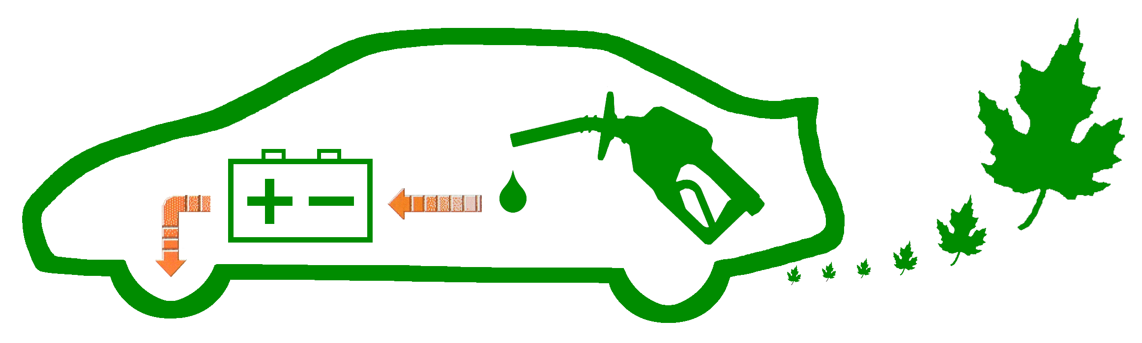
Disclaimer:

All the information stated in this document was provided by Prius owners. None were affiliated with Toyota Motor Corporation, except as customers.

This document is not sanctioned by Toyota Motor Corporation or any of its affiliates.

The ideas, suggestions, and opinions offered in this document have not been endorsed by the manufacturer of those specific components or Toyota Motor Corporation.
Any harm or damage that may result from the application of or the following of any ideas, suggestions, or opinions contained in this document is the sole responsibility of the individual that applied or followed said ideas, suggestions or opinions.

The authors of this document hereby declare that they cannot and will not be held liable, in any fashion, for the content or the use of this document.

Table of Contents:

DRIVING 2
Just Drive It ! 2
Startup 2
Shutdown 2
Hybrid Driving 3
Stealth Driving 4
Cruise-Control 4
MPG Measurement 5
Brakes 5
Increasing MPG 6
"B" Mode 8
Radio 9
NURTURING 10
Filling the Gas Tank 10
Tire Care 11
Alternate Tires 12
Multi-Display Care 16
Washing 16
Polishing 17
Long-Term Storage 17
Valet Use 17
MAINTENANCE 18
Dealer Service 18
Oil Changes 18
OTHER STUFF 19
Keys 19
After-Market Items 19
Transmission 20
Information Sources 21
Informational Materials 22
GLOSSARY 29

DRIVING

Just Drive It !

 | Vital Info | Ignore the advanced technology!  It's too easy to get preoccupied with everything Prius automatically does for you, especially with the Multi-Display providing constant performance information. The hybrid system was designed so you could to drive it like a traditional car. That way, you can enjoy the remarkably smooth & quiet ride. Let the computer worry about how to save gas and reduce emissions.

Startup

 | Engine Warm-Up | Reducing Emissions is the highest priority for Prius. It strives to remain a SULEV (Super Ultra Low Emission Vehicle) at all times, which means the catalytic-converter must be kept warm even if that requires consuming some gas to accomplish that. Fortunately, you still get better than average mileage, even if the engine doesn't shut off right away.
 | Winter Heat | Creating heat for the emissions system and heat to keep you warm is fastest and most efficient if you simply drive gently immediately after starting the Prius in the winter. Allowing the engine to run while the Prius is parked takes longer and is less efficient. "Just Drive It!"
 | Turning the Key | The user-manual states to turn the key and hold it until you hear a beep. Realistically, you can actually let go of the key immediately. Once the computer accepts your request, the engine will start-up after preparation is complete. Think of it as clicking a button on a computer-mouse. The catch is you must still wait for the "READY" prompt before shifting into Reverse or Drive.
 | Blue Light | The blue light, which looks like a thermometer in liquid, is located to the right of the speedometer. It indicates the engine is still cool. This is normal during engine warm-up, it is not a warning. It will usually disappear about in 5 minutes, depending on the outside temperature and if the Prius was recently used. Driving slowly immediately after startup, rather than just waiting while parked, is the most efficiently method of reducing warm-up time. Idling until warm-up is complete before driving takes longer and wastes gas.

Shutdown

 | Remote Confirm | Use the remote when leaving your Prius. Clicking the "lock" button on it will confirm that all the doors really did get shut all the way. If they didn't, the internal overhead light may remain on. That will drain the small 12-volt auxiliary battery if left that way long enough in a 2001 or 2002 Prius. Beginning with the 2003 model, the light will automatically shut itself off even if a door is left ajar.

Hybrid Driving

 | From a Stop | The gasoline engine is most efficient when running near full potential. So if you can't press lightly enough on the pedal to accelerate using only electricity, go ahead and press a little harder than usual. That brisk - but not aggressive - increase in speed will save a small amount of gas, resulting in an overall efficiency gain.
 | Climbing Hills | The hybrid system has 2 electric motors. When you encounter a large hill, those motors are automatically taken advantage of. The gasoline engine will rev to its most efficient high-power RPM. That provides thrust directly to the tires, generates electricity for the motor, and recharges the battery-pack all at the same time. So to the surprise of many new owners, large hills don’t drain the system. You’ll still have plenty of reserve power available when you reach the top.
 | Cruising | A beneficial technique for efficient cruising is to feather the accelerator pedal at particular times.  Learning to do this is simple and will quickly become second nature with very little practice. (In fact, you may already have that foot control if you in-line skate or bicycle occasionally.) To do it, just lightly reduce pressure on the accelerator-pedal whenever you encounter a section of road that’s perfectly flat or has a slight decline. The MPG indicator will sometimes jump all the way to the +100 mark, even though your speed ends up dropping only 1 MPH. Then lightly push the accelerator-pedal to efficiently regain that speed afterward. Overall, MPG will climb a little bit when each time you do that.  You’ll end up taking advantage of the hybrid design. Changes in the road pitch naturally cause changes in speed anyway. Using the multi-display and large digital speedometer helps you discover when gains from that are possible.
 | Parking | When you place the Prius in Park after "stealth" driving, the engine may startup. This is just simple process needed to insure the engine optimally tuned. If you don't want to wait the 10 to 20 seconds for engine shut off, you may immediately do it yourself. The hybrid system will just perform that "housekeeping" when you startup later.
 | Without the Pack | The electric motor doesn't actually need electricity from the battery-pack. The gasoline engine creates electricity immediately while you drive. So quite frequently, on the multi-display you'll see that the motor is being fed directly from the engine and the battery-pack isn't even being used. And sometimes, while both the engine and motor are providing thrust, the engine will also recharge the battery-pack at the same time.
 | A/C Instead | At highway speeds, using the A/C (air-conditioner) or vent to remain cool will result in slightly higher MPG than having the windows open.
 | Recirculate | Avoid using this mode during the winter, since it causes frost on the inside of the windows.  Recirculating warm inside air will prevent the engine from needing to run as often; however, the moisture you naturally exhale will build up after awhile. Allowing the fresh cold air from outside to be drawn in will keep the humidity low. The resulting minor MPG penalty is well worth always having clear glass.

Stealth Driving

 | Engine Off | While the gasoline engine is off and you’re driving using just battery power, the mode you’re in is called "stealth" (since movement is completely silent).  Invoking "stealth" is easy once the engine has warmed up (and you aren't running the A/C or Heater too heavily). While driving, just find a street section without any inclines then lift your foot from the accelerator-pedal. The engine will shut off within a few moments. Once it does, lightly place your foot back on the accelerator-pedal to continue driving with only electricity. Another way to invoke stealth is to just stop completely, that will make the engine shut off.
 | Up to 42 MPH | The 33 kW electric motor is designed to propel the Prius up to 42 MPH (68 km/h). It takes a steady foot though. Slower speeds, like 35 MPH (56 km/h) and 30 MPH (48 km/h), are easier. Beyond that maximum speed or in conditions when additional power is needed, the motor works in combination with the gasoline engine. Though, you will discover above 42 MPH (68 km/h) that there are times when the engine will spin (pistons in motion) without any fuel being consumed; it is a normal function of the Planetary-CVT.
 | Acceleration | Accelerating in "stealth" can be very slow. Also using the gasoline engine is both quicker and (surprisingly) more efficient, so don't be afraid to consume a little bit of gas. Remember that even if you use the battery and get "+100 MPG", the engine must run later to recharge it. So short-term gains may actually result in an overall loss.
 | A/C & Heater | Only the lowest setting for the air-conditioner & heater work in "stealth". Higher settings and airflow durations longer than a minute or two will require the gasoline engine to run.
 | Be Careful ! | Be careful while driving in "stealth", especially in parking lots. Some people use only their ears to verify it's safe, not their eyes! So having a car that's completely silent means you'll probably have someone step out in front of it without even realizing you’re driving right at him or her.

Cruise-Control

 | After Market | Cruise-Control is now available for 2001 model Prius, it wasn't originally. So if you'd like to add it now, just ask your dealer. It can also be added afterward to the 2002 & 2003 model.
 | 24 MPH minimum | Slowing down below 24 MPH (39 km/h) will cause the memory to reset. So if you have to slow down or stop, you'll need to set the speed again rather than using the resume feature.
 | MPG | Some owners have observed an increase in MPG from using the cruise-control, others have not. Results vary depending on your particular driving habits and road conditions.
 | Stealth | If you don't have a sensitive foot but would still like to enjoy stealth driving on a light traffic road, just set the cruise-control. This can be done all the way up to 42 MPH (68 km/h) on flat or declining terrain without making the engine startup.
 | Smoooooth | The CVT (Continuously Variable Transmission, Planetary Type) in the THS (Toyota Hybrid System) makes the cruise-control in Prius remarkably smooth. You'll especially notice the "no shifting" characteristic of the drive when going up hills and accelerating aggressively.

MPG Measurement

 | Lifetime | LIFETIME is the most useful measurement. Total miles driven, divided by total gallons consumed, informs you how efficiently the car has performed overall.
 | Tank | TANK is the measurement between each fill up. You press the RESET button when the tank is full. The results are informative, but not perfectly accurate. In cold weather, the bladder inside the gas tank shrinks. This reduces the overall capacity making the "full" level variable. Also, "full" can be misrepresented if the pump doesn't shut off at the proper time. These factors make calculations based on fill-up less accurate.
 | Trip | TRIP is mostly for fun, since a multitude of variables can affect the measurement to a single destination. Watch the 5-minute summary segments shown on the multi-display. Remember though, if you were to start a drive downhill, with a tail wind, a warm engine, a fully charged battery-pack, and a warm outside temperature, the MPG would be very impressive for that particular trip. But then if the return trip back was uphill, against the wind, with a cold engine, a drained battery-pack, and a cold outside temperature, the MPG would appear very disappointing. In summary, trip results can vary greatly. The overall average is what really matters.
 | Sudden Drop | Tire pressure may have dropped. For every 10 F degrees colder, pressure will automatically drop 1 PSI. Verify you still have as much air in the tires as you think they do.  Increased use of the heater or air-conditioner (which includes the defroster) will force the engine to run more often. Try a less demanding setting.  When the temperature drops below freezing, you may notice the engine has to run quite a bit longer to warm up the catalytic-converter. This is to keep the Prius emissions Super-Ultra clean. Avoid driving short trips; instead, take advantage of the time after warm up is complete by running several errands at once.

Brakes

 | Regenerator | When you reduce pressure on the accelerator-pedal or use the brake-pedal, excess speed turns a motor, causing regeneration of electricity to recharge the battery-pack. The regenerator takes advantage of the kinetic energy that would have otherwise been lost. The brake pads & shoes are not used as much as in a traditional vehicle. This not only makes the Prius more efficient, it also indicates the brakes will last longer.
 | Foot Pressure | You’ll hear comments about the brakes feeling "grabby" from some people taking test-drives. They aren’t aware that Prius brakes don’t require heavy pressure like traditional brakes; instead, the same pressure you use for the accelerator-pedal is all that’s needed. You’ll discover this is a pleasant improvement after just a day or two of driving. In fact, you may even ask yourself later why brakes weren’t always made like that.

Increasing MPG

 | Driving | Brisk Acceleration is an often misunderstood benefit. There's no need to hold back. A gasoline engine works more efficiently when running at higher RPM, about 70 percent of maximum. Take advantage of that by getting to cruising speed quickly (but not aggressively, please drive safely). And remember, while the engine running it is also generating electricity for later use.  Coast whenever you have the opportunity. Using the feather technique helps. By lifting your foot lightly from the accelerator-pedal, you can invoke an efficient computer-controlled glide without decelerating much at all (less than 1 MPH). With good road conditions and a bit of practice, you'll find yourself doing this instinctively.  Look Ahead. If you see a light turning red or a need to slow down in the distance, there's no reason to continue holding the accelerator-pedal. Remove your foot and allow the generator to decelerate the Prius. That will increase your MPG, charge the battery-pack, and prolong the life of your brakes.
 | Tire Care | 42/40 PSI (2.9/2.8 bar) is what many Prius owners strongly recommend. The original tires for the Classic Prius support a maximum cold pressure of 50 PSI (3.4 bar) and for the Iconic Prius 44 PSI (3.0 bar). So that pressure increase is well within the design specifications. Many of the alternate tires available support a maximum cold pressure of 44 PSI (3.0 bar) too. Whatever you decide, just remember that low pressure results in a MPG drop and the tires wear out faster. Tires will not bulge like in decades past; manufacturers provide much better quality now which maintains a flat contact surface all the way up to the maximum pressure.  Every 5,000 miles (8,000 km) the tires should be rotated, for best lifetime performance. Rotation is preferred in a roll-back, roll-forward pattern.  Measuring the PSI should be done only when the tires are cold, since driving heats up the air inside the tires making the results inaccurate... giving you the impression more pressure is higher than it really is.  Check Often since temperature causing pressure to drop, 1 PSI for every 10 F degrees. Air will naturally leak out from normal use too.
 | Highway Speed | 62.1 MPH (100 km/h) is the optimal (most fuel efficient) fast speed. So you'll notice a MPG drop driving at 70 MPH (113 km/h), though it isn't huge. But faster than 75 MPH (121 km/h), it is. If you drive fast, you'll consume quite a bit more gas. (This is true of every vehicle, not just Prius.)
 | A/C & Heater | Minimal use is the key. Using the heater or the air-conditioner (which includes the defroster) on more than the lowest setting may prevent the engine from shutting off. That will reduce MPG; so try to avoid high demand use. Fortunately, on the highway using the air-conditioner is still more efficient than opening the windows.
 | 87 Octane Gas | Prius was designed to run with 87 Octane gasoline (85 in high altitudes). Some owners have experimented with higher octanes, but found there wasn't any MPG improvement. Also, bear in mind that higher octane gasoline may trigger an emission sensor alert. So just save money and continue using the less expensive 87 octane gas.
 | "B" Mode | Avoid using this mode unless absolutely necessary; it will cause MPG to drop.
 | External Loads | Hitch Racks & Roof Carriers cause a lot of aerodynamic drag. So, expect a MPG drop when you use one.
 | Engine Warm-Up | Short Trips are horribly inefficient for all vehicles. Prius is no exception; however, it’s far more noticeable since the Multi-Display provides immediate feedback showing you lower MPG. The efficiency benefits of the system are not utilized until after warm-up is complete, that usually takes about 10 minutes. So try to run several errands at once to take advantage of an already warmed up gasoline engine.  SULEV (Super Ultra Low Emission Vehicle) is what Prius strives to remain whenever active, even during warm-up. That means the catalytic-converter must be kept hot even if that requires using some gas to do it. Fortunately, you still get better than average mileage, even if the engine doesn't shut off right away.
 | 5W-30 Oil | 5W-30 oil is strongly recommended (real or synthetic).  If a service person puts 10W-30 in by mistake, you may complain since it will negatively impact your MPG slightly and may affect performance in below freezing temperatures. The text on the engine oil cap clearly states 5W-30 should be used.
 | Synthetic Oil | Owners have observed minor MPG improvements by switching to synthetic oil.  Plus, since it protects the engine better than real oil, makes extremely cold startups even easier, and change intervals are only 7,500 miles (12,000 km), switching from real oil should be a simple choice.
 | Oil Level | Too much oil can decrease MPG. Insure that the level is never above the maximum mark on the dipstick.  Unfortunately, overfilling is a problem commonly overlooked. Oil change services routinely pump oil from large barrels, rather than using quart-size bottles. That makes overfilling very easy to do. Taking a moment afterward to check afterward is truly beneficial.
 | Measurement | The multi-display averages optimistically, so it will usually read about 2 MPG too high for most owners. The "bladder effect" (caused by the bladder in the gas tank shrinking due to temperatures below freezing), which is very noticeable in the Spring & Fall, causes the readout value and manual calculations to vary greatly for individual measurements. Averaging several fill up amounts documented at the gas station will provide the actual MPG you've been getting. For an example of how to do this, refer to this webpage... http://john1701a.com/prius/prius-data.htm
 | Break-In | For the first 200 Miles (322 km):  - avoid rapid deceleration (hard stops)  - avoid high speeds (more than 70 MPH, 113 km/h)  For the first 600 Miles (966 km):  - avoid rapid acceleration  - avoid racing (high RPM) the engine  After roughly 10,000 Miles (16,100 km):  - enjoy a MPG increase, from the moving parts having loosened  Even at 30,000 Miles (48,300 km):  - you may continue observe minor MPG increases as the car ages
 | YMMV | "Your Mileage May Vary" That simple statement about the EPA ratings shown on the new vehicle window sticker is often overlooked, yet it makes a significant difference depending on the type of driving you do. Reading this quote provided by the EPA about Prius reveals why: "Actual Mileage will vary with options, driving conditions, driving habits and vehicle's condition. Results reported to EPA indicate that the majority of vehicles with these estimates will achieve between 44 and 60 mpg in the city and between 38 and 52 on the highway."  EPA tests are generalizations (performed under ideal conditions) intended to make vehicle comparisons easier, not to specify what MPG you will actually get. In fact, they rarely reflect the MPG in real-world driving experiences. The following explains how those tests are performed... notice how results can be quite a bit lower if you live in the north or if you drive fast:  The fuel economy estimates are based on results of tests required by the U.S. Environmental Protection Agency (EPA). These tests are used to certify that vehicles meet the Federal emissions and fuel economy standards. Manufacturers test pre-production prototypes of the new vehicle models and submit the test results to EPA. EPA re-tests about 10% of the tested vehicles to confirm manufacturer's results in EPA's lab. The vehicles are driven by a professional driver under controlled laboratory conditions, on an instrument similar to a treadmill. These procedures ensure that each vehicle is tested under identical conditions; therefore, the results can be compared with confidence.  There are two different fuel economy estimates for each vehicle in the Fuel Economy Guide, one for city driving and one for highway driving. To generate these two estimates, separate tests are used to represent typical everyday driving in a city and in a rural setting. Two kinds of engine starts are used: the cold start, which is similar to starting a car in the morning after it has been parked all night; and the hot start, similar to restarting a vehicle after it has been warmed up, driven, and stopped for a short time.  The test used to determine the city fuel economy estimate simulates an 11-mile, stop-and-go trip with an average speed of 20 miles per hour (mph). The trip takes 31 minutes and has 23 stops. About 18 percent of the time is spent idling, as in waiting at traffic lights or in rush hour traffic. The maximum speed is 56 mph. The engine is initially started after being parked overnight. Vehicles are tested at 68 F to 86 F ambient temperature.  The test to determine the highway fuel economy estimate represents a mixture of "non-city" driving. Segments corresponding to different kinds of rural roads and interstate highways are included. The test simulates a 10-mile trip and averages 48 mph. The maximum speed is 60 mph. The test is run with the engine warmed up and has little idling time and no stops (except at the end of the test).  NOTE: To make the numbers in the Fuel Economy Guide more useful for consumers, EPA adjusts these laboratory test results to account for the difference between controlled laboratory conditions and actual driving on the road. The laboratory fuel economy results are adjusted downward to arrive at the estimates in the Fuel Economy Guide and on the labels seen on new cars, light trucks, and vans. The city estimate is lowered by 10% and the highway estimate by 22% from the laboratory test results. Experience has proven that these adjustments make the mileage estimates in the Fuel Economy Guide correspond more closely to the actual fuel economy realized by the average driver.  For more information, please refer to... http://www.fueleconomy.gov/feg/info.shtml

"B" Mode

 | Engine Braking | The "B" mode works like an exhaust brake on a large truck (except, it's totally silent). The engine is used to slow down the vehicle, allowing you to reduce reliance on the regular brakes. So for steep declines, like driving down a mountain, it's a great way to avoid overheating caused by friction from the brake drums & shoes.  You can engage or disengage engine-braking at anytime while driving.  There is no charging benefit over regular braking.  Avoid using this mode unless absolutely necessary; it will cause MPG to drop.

Radio

 | Channel Scan | Press the "SCAN" button next to the tape player. It will begin scanning for radio channels. When it finds a station, a few seconds will play, then it will automatically scan for the next. Press the "SCAN" button again when you want the scanning to stop.  If you press then hold the "SCAN" button, only your preset radio channels will be scanned.

NURTURING

Filling the Gas Tank

 | 87 Octane Gas | Prius was designed to run with 87 Octane gasoline (85 in high altitudes). Several owners have experimented with 90 & 93 Octane; however, there wasn't any improvement to MPG. Since engine knocking is non-existent with Prius, there's no benefit in that respect either. Additionally, higher octane may trigger an emission sensor alert. Therefore, save some money by using 87 Octane.
 | Low-Sulfur Gas | Without the loss of performance or power, low sulfur gasoline helps to reduce emissions by preventing efficiency loss within the catalytic-converter (a pollution control device) due to sulfur build up. This also extends the life of the emission components.
 | 10% Ethanol Mix | 90% Gasoline mixed with 10% Ethanol, known as E10, will not harm any part of the Prius fuel or emission system. Owners in the metro area of Minnesota, where E10 is required by law, have used this type of fuel in their Prius for years without experiencing any problems at all. So there is no need for concern
 | Empty | Don't ever run out of gas!  Not having the engine available makes driving a Prius using just electricity very risky. Without gasoline it is very easy to push the motor & battery-pack beyond the tolerances they were designed to operate. The motor is never supposed to exceed 42 MPH (68 km/h) all by itself and the battery-pack is never supposed to be fully depleted. Also, without gas there's no way to prevent certain mechanical & electrical components from overheating. Since Prius can go quite a bit further between fill-ups than most vehicles, there's really no reason you should ever run out of gas anyway. But if you do, drive very slowly and just enough to get out of harm's way.
 | Another Gauge | When there is less than half a tank of gas remaining, the gas gauge is less accurate due to the flexible nature of the bladder within. A helpful measurement alternative is to base refill timing on the mileage you drive. Just reset one of the three odometers (A, B, or the one on the multi-display) every time you get gas.  400 miles (644 km) in the summer and 350 miles (563 km) in the winter is a good distance to start with. You'll quickly figure out what works well for your particular needs.
 | Bladder | Inside the gas tank is a flexible bladder. It contracts and expands to fill the empty void that would otherwise be filled with vapor as gasoline is consumed. The reduction of vapor emissions helps to keep Prius extraordinarily clean.  Overfilling should be avoided, since adding gas after the pump automatically stops can create pressure within the bladder. This could cause gas to be expelled afterward. So just don't top off.  Capacity reduces during the winter since cold temperatures cause the bladder to contract, up to 1.5 gallons (5.7 liters) in extreme conditions (below 0F / -18C degrees). That means you'll have to fill up sooner. But when temperatures are that dangerously low, you should really fill up at the halfway point anyway.
 | Gas Cap & Door | Twist the cap until it clicks. If it is not tightly secured, you may trigger an alert from the emission sensor. After all, Prius wouldn't be so clean if vapor were allowed to leak out. In the event of an alert, turn off the Prius and tighten the cap. Normal status should return after you restart.  Tuck the tether holding the cap to the car into the interior. Simply allowing it to be pushed by the door may cause a tangle making the door hard to open later.  Lubricate the hinge. After extended exposure to dust, sand, and salt, the spring may struggle to open the door due to the hinge being dry.  Adjust the latch. It’s possible to accidentally bend it. Too much can make the door difficult to open. You may need to straighten it.

Tire Care

Prius ships with tires that reduce rolling-resistance to maximize MPG. Using special tires means life-expectancy is similar to high-performance vehicles rather than everyday family cars. The 160 wear-rating is very soft compared to typical tires. To prevent accelerated wear, maximizing miles before replacement, follow these suggestions:

 | PSI Minimum | 35/33 PSI (2.4/2.3 bar) is the PSI for the Prius tires (noted on the driver's door-jam of the car itself).  42/40 PSI (2.9/2.8 bar) is what many Prius owners strongly recommend. The original tires that Prius comes with support a maximum cold pressure of 50 PSI (3.4 bar), so that increase is well within the design specifications. Many of the alternate tires available support a maximum cold pressure of 44 PSI (3.0 bar). Whatever you decide, just remember that low pressure results in a MPG drop and the tires wear out significantly faster.  Note: Measuring PSI should always be done when the tires are cold, since driving heats up tires making the results inaccurate due to the air inside expanding (which creates a false impression of higher pressure).
 | Monthly Checking | At the very least, check your tires monthly. Pressure loss is normal and especially rapid when temperatures drop. Uneven wear is an indication that either you’ve been driving with tires below the minimum PSI or balancing/alignment is required. Also, don’t forget about checking the spare tire in the trunk too.
 | PSI Convenience | Tire pressure needs to be routinely checked (for all vehicles, not just Prius). Temperature drops cause PSI to decrease. Heat caused by driving increases PSI, making measurements inaccurate until cool. MPG & Safety are directly dependent on properly maintained PSI. Prius owners have found a way to make this simple: use a cordless-inflator.  One of many examples of available is the "Campbell Hausfeld Cordless-Inflator" is available at Wal-Mart for just $40. It's small & powerful, which allows you adjust PSI in the convenience & comfort of your own garage when the tires are cool. And as an added bonus, the battery in the cordless-inflator can also be used as a portable 12-volt power-supply to plug your automotive accessories into.
 | Turning | Never turn the wheels unless they're rolling. That causes unnecessary wear, just as with other vehicles. The power-steering is so powerful, you can't feel the friction caused by turning. But your tires can. So, make sure the wheels are moving before you turn them.
 | Lug Nuts | When initially tightening the lug nuts after having put a wheel back on and when you retorque them after having driven around 100 miles, make certain the pressure you use is 76 ft-lb (103Nm).
 | Rotation | Every 5,000 to 7,500 miles (8,000 to 12,000 km) the tires should be rotated, for best lifetime performance. Rotation should be in a "roll-back, cross-forward" pattern. (That's front tires to the rear without switching sides, and rear tires to front switching sides.)
 | Alignment | 0.05 DEGREES of Toe IN each side, for a total of 0.10 DEGREES.  If steering feels like it wanders at high speeds, it's probably because the alignment isn't adjusted correctly. Remember, "within factory-specified tolerance" is an answer you don't have to accept from a service provider; you can insist that alignment be adjusted to this "exact" setting.
 | Replacements | If you decide to replace the original tires with a different brand (which many owners have), make sure the new ones provide support for up to 1102 lbs. (500 kg) at the PSI you decide to use. Tires with different width, height, and revolution specifications with fit on the aluminum rims, but they may reduce MPG and prevent battery-only driving. So carefully research before making a purchase.

Alternate Tires

Prius comes standard with XL (Extra-Load), LRR (Low Rolling Resistance) tires. They promote high MPG and provide a safe, comfortable, quiet ride; however, they only last 30,000 miles (48,280 km). Some Prius owners have found this shorter-than-typical duration disappointing, so they've researched alternative tires. Below is a summary of that information.

DISCLAIMER: The ideas, suggestions, and opinions offered here have not been endorsed by the manufacturer of those specific components or Toyota Motor Corporation. Any harm or damage that may result from the application of or the following of any ideas, suggestions, or opinions contained in this document is the sole responsibility of the individual that applied or followed said ideas, suggestions or opinions. The authors of this document hereby declare that they cannot and will not be held liable, in any fashion, for the content or the use of this information.

 | PSI | Classic Prius is a heavier than average vehicle. That means XL rated tires are required if the standard PSI (Pounds per Square Inch air-pressure) is used. But if you choose a tire that offers a greater PSI capacity, the weight can be supported that way instead.  An absolute minimum of 35 PSI (2.4 bar) with the original tires is required to provide the 1,102 pounds (500 kg) of support needed for the front-end of the Prius. Using standard tires instead at that pressure only provides support for 1,019 pounds (462 kg). Increasing to 42 PSI (2.9 bar) will compensate for that extra weight, allowing Non-XL tires to be used.  42/40 PSI (2.9/2.8 bar) is what many Prius owners strongly recommend. (That's 42 front & 40 back, since a 2 PSI bias is required for the front tires.) The original tires that Prius comes with support a maximum cold pressure of 50 PSI (3.4 bar), so that increase is well within the design specifications. Many of the alternate tires available support a maximum cold pressure of 44 PSI (3.0 bar). So using 42/40 is no big deal. In fact, some owners even use 44/42 PSI (3.0/2.9 bar).
 | LRR | Classic Prius comes with LRR (Low Rolling Resistance) tires. This type maximizes MPG. Switching to Non-LRR tires means you can expect a drop in fuel efficiency by approximately 3 MPG. Owners have found this an acceptable trade-off for getting better handling and significantly increased tread life.
 | Size | 175/65R14 is the standard size tire for Classic Prius. You'll find the choices available for that size very limited. Fortunately, the 5.5 inch (14 cm) aluminum rims of Prius allow you to use an alternate size. Both 185/60R14 and 185/65R14 tires fit very nicely.
 | Cost | Tire designs vary tremendously, so the price does too. Finding a better Prius tire does not necessarily mean you'll have to spend more money. In fact, owners have discovered some alternative tires are actually less expensive that the original tires.
 | Treadwear | 160 is the treadwear rating for Classic Prius tires. That's simply too low compared to the typical family vehicle. It's actually what you find on high-performance sports cars and high-end luxury vehicles, where the ride is much more important than long tread life. 450 is much more realistic to meet everyday expectations. 800 is what you'll find on the ultra-long-life tires.  The rating number represents the wear resistance of the tire. It does not correlate directly with the amount of mileage you'll be able to drive. Don't rely exclusively on this value when selecting a tire. Check the warranty, it will usually state an approximate distance expectation.  Also, using PSI too low will cause significant wear of the tire tread. Consider yourself warned!
 | Revs | Revs (Revolutions per Mile) indicate the precise "rolling" size of the tire. This measurement is needed since not all tires with the same specification are actually the same. (Notice how both the Michelin & Dunlop 185/65R14 tires appear to similar, but the revs numbers aren't.)  902 is the Revs value for Classic Prius tires. When selecting an alternate, a number very close to that is required to insure the speedometer and odometer remain accurate. (Being off by a small amount is acceptable since that value will change as tread wears down anyway.)
 | Original Tire | Bridgestone Potenza RE92  Classic Prius comes with these tires standard. They are sometimes referred to as OEM (Original Equipment Manufacturer) tires.  175 / 65 R14 XL  84S speed & load rating  50 PSI (3.4 bar) maximum pressure  38/37 PSI front/back (2.6/2.6 bar) recommended  42/40 PSI front/back (2.9/2.8 bar) preferred  1102 lbs. (500 kg) maximum load  LRR (Low Rolling Resistance)  10/32 inch (8 mm) tread depth  902 revs per mile  "A" Traction  "A" Temperature  160 Treadwear  30,000 mile (48,280 km) warranty
 | Alternate Tire | Goodyear Allegra  These tires manufactured for purchase only at Wal-Mart & Sam's Club. They've proven to be an excellent alternative choice by the Prius owners that have tried them.  175 / 65 R14  81T speed & load rating  44 PSI (3.0 bar) maximum pressure  42/40 PSI front/back (2.9/2.8 bar) recommended  1019 lbs. (462 kg) maximum load  Non-LRR (Standard Rolling Resistance)  10/32 inch (8 mm) tread depth  "A" Traction  "B" Temperature  560 Treadwear  75,000 mile (120,700 km) warranty  Personal experiences with these tires are documented here... http://john1701a.com/prius/prius-maintain.htm#AlternateTires
 | Alternate Tire | Michelin Harmony  There are a number of alternates available from different manufacturers. This example is the successor to the popular "X-One" tire from Michelin, which many Classic Prius owners have tried and recommended to others. (Note: You may also use a 185 size, which will provide full support at just 35 PSI. But the trade-off is a MPG reduction.)  175 / 65 R14  81S speed & load rating  44 PSI (3.0 bar) maximum pressure  42/40 PSI front/back (2.9/2.8 bar) recommended  1019 lbs. (462 kg) maximum load  Non-LRR (Standard Rolling Resistance)  11/32 inch (9 mm) tread depth  902 revs per mile  "A" Traction  "B" Temperature  680 Treadwear  80,000 mile (128,748 km) warranty
 | Alternate Tire | Michelin HydroEdge  This is a popular choice for the Iconic Prius, an excellent choice for those wanting improved traction and much longer tread life. It can be used on the Classic model too; however, only the larger size is available. The size & rubber difference will reduce MPG a little bit. PSI higher than 35 may be used to compensate for this.  175 / 65 R14  85T speed & load rating  44 PSI (3.0 bar) maximum pressure  42/40 PSI front/back (2.9/2.8 bar) recommended  1124 lbs. (510 kg) maximum load  Non-LRR (Standard Rolling Resistance)  11/32 inch (9 mm) tread depth  893 revs per mile  "A" Traction  "B" Temperature  800 Treadwear  90,000 mile (144,841 km) warranty
 | Alternate Tire | Dunlop SP10  This is the standard tire for the Classic Prius in Canada.  175 / 65 R14  84S speed & load rating  50 PSI (3.4 bar) maximum pressure  42/40 PSI front/back (2.9/2.8 bar) recommended  1102 lbs. (500 kg) maximum load  LRR (Low Rolling Resistance)  11/32 inch (9 mm) tread depth  913 revs per mile  "A" Traction  "B" Temperature  220 Treadwear

 | Alternate Tire | Dunlop SP Sport A2  There are 2 size choices available for this Classic Prius tire; size, speed rating, maximum load, and revs differ. So you are not limited to particular specifications, though neither is the exact size as the original tire (Potenza).
 |  | 185 / 65 R14  85H speed & load rating  44 PSI (3.0 bar) maximum pressure  1124 lbs. (510 kg) maximum load  Non-LRR (Standard Rolling Resistance)  10/32 inch (8 mm) tread depth  23.4 inch (59 cm) diameter  894 revs per mile  "AA" Traction  "A" Temperature  420 Treadwear  50,000 mile (80,467 km) warranty | 185 / 60 R14  82H speed & load rating  44 PSI (3.0 bar) maximum pressure  42/40 PSI front/back (2.9/2.8 bar) recommended  1047 lbs. (475 kg) maximum load  Non-LRR (Standard Rolling Resistance)  10/32 inch (8 mm) tread depth  919 revs per mile  "AA" Traction  "A" Temperature  420 Treadwear  50,000 mile (80,467 km) warranty
 | Alternate Tire | Nokian NRHi  These tires are LRR, just like the OEM tires. So MPG will be maximized, unlike the other alternates available. Unfortunately, these are only “summer” tires.
 |  | 175 / 65 R14  82H speed & load rating  51 PSI (3.5 bar) maximum pressure  42/40 PSI front/back (2.9/2.8 bar) recommended  1047 lbs. (475 kg) maximum load  LRR (Low Rolling Resistance)  11/32 inch (8.7 mm) tread depth  "A" Traction  "A" Temperature  320 Treadwear  50,000 mile (80,467 km) warranty  185 / 60 R14  82H speed & load rating  51 PSI (3.5 bar) maximum pressure  42/40 PSI front/back (2.9/2.8 bar) recommended  1047 lbs. (475 kg) maximum load  LRR (Low Rolling Resistance)  11/32 inch (8.7 mm) tread depth  "A" Traction  "A" Temperature  320 Treadwear  50,000 mile (80,467 km) warranty |  | 185 / 65 R14 XL  90H speed & load rating  51 PSI (3.5 bar) maximum pressure  42/40 PSI front/back (2.9/2.8 bar) recommended  1323 lbs. (600 kg) maximum load  LRR (Low Rolling Resistance)  11/32 inch (8.7 mm) tread depth  "A" Traction  "A" Temperature  320 Treadwear  50,000 mile (80,467 km) warranty

Multi-Display Care

 | Cleaning | The best way to remove fingerprints from the touch-screen is actually simpler that some owners realize. You don't need a special solvent or material. Just a plain old soft cotton fabric, like an old clean t-shirt, and some purified drinking water is all you need.  Also, make sure to only clean when the Multi-Display is off. This will make the fingerprints easy to see and will prevent the "Reset" button from accidentally being pushed.

Washing

 | Battery Vent | Owners have observed that the cooling vent for the battery-pack does not cause any problems when going through an automatic car wash. The design prevents water entry. So there isn’t any need for concern.  When washing the Prius by hand, avoid spraying water directly at the vent. Though difficult, it could still be possible for you to aim a high-pressure water stream in a way that water may enter.
 | Antenna | Removing the antenna is easy, just unscrew it. Then you don't have to worry about it while going through an automatic car wash.

Polishing

 | Owner Tests | "Nu Finish" has worked well. The great polished look lasts for about 6 months, enough to get through an entire winter. But when you wipe the dried residue off, it actually leaves lightly faded streaks at first. Don't let that deter you. It disappears, leaving a protective layer after a few days.

Long-Term Storage

 | Less than 3 Weeks | Nothing is needed, at room temperature. The engine should startup just fine. Be aware that this duration can be shortened by the age of the auxiliary-battery and the extreme cold.
 | More than 3 Weeks | It is helpful to disconnect the small, 12-volt auxiliary battery on the driver side in the trunk. With it disconnected, there will no longer be a drain from the alarm system. (Make note of the radio buttons you have programmed, since you'll need to manually restore them after reconnecting the 12-volt auxiliary battery.)  Draining the 273.6-volt battery-pack while in long-term storage is never a concern. When you shut off the Prius, an electric-relay automatically deactivates to cut the connection to the hybrid system. So it isn’t even connected to the rest of the system until you turn the key again.
 | Larger Battery | EL014-03 is a TSB (Technical Service Bulletin) that advises your dealer about the larger 12-volt auxiliary battery available for the Classic Prius. 28800–21190 is the part number. A mounting kit is also needed, part number 04003–23147.

Valet Use

 | Engine On | Stealth can confuse valet drivers, since they expect noise & vibration rather than dead silence. Keeping the engine running could prevent a mishap. Valets may repeatedly turn the key trying to start the Prius not realizing it's already running. Or worse, they may get out while the Prius is still in "Drive" because they think it’s off. To minimize this risk, set the defroster to the maximum cold or hot setting. This forces the engine to continue running.
 | Valet Key | The Valet (gray) colored key prevents a valet driver from opening your trunk. It is cut differently from the Master (black) colored key.
 | Trunk Disable | The trunk open lever next to the driver's seat can be disabled. Just insert a Master (black) key into the lock on the trunk, turn it counter-clockwise, then remove it. Later, turning the key clockwise will re-enable the lever.

MAINTENANCE

Dealer Service

 | Air Filters | Based on the free maintenance covered by the warranty included for United States Prius models 2001, 2002, and 2003, both air filters will be replaced for you. The 22,500 mile (36,210 km) service (using the standard schedule) is when the air-conditioner filter should be replaced. The 30,000 mile (48,280 km) service (using the standard schedule) is when the engine air filter should be replaced. Be sure the dealer knows when each occurs, since it is easy to mix-up the two "air" filters.

Oil Changes

 | 5 free Changes | 5 free oil & filter replacements are covered under the included Toyota warranty for United States Prius models 2001, 2002, and 2003.
 | 7,500 Miles or  6 Months | 7,500 miles (12,070 km) or 6 months, whichever comes first.  Having the engine shut off frequently and not using it as the sole propulsion source is the reason oil lasts so long. It simply isn't exposed to the strenuous engine conditions found with traditional vehicles.
 | Overfilling | This is an unfortunate reality. Too much oil causes MPG to be reduced. Way too much oil causes damage to the engine. So it is in your best interest to make sure the level never exceeds the "Full" marker on the dipstick. 3.9 quarts (3.7 liters) is the maximum capacity.  Oil pumped from bulk barrels into your engine is not always carefully measured, as it would be coming from a bottle instead. So make sure to check for yourself after an oil-change service is complete. If the level is beyond "Full", insist that they remove the excess. The ideal level is slightly below "Full", that's 1/4 inch (6 cm) lower.  If you provide your own oil (which is common for those preferring synthetic), only supply the mechanic with about 3.5 quarts (3.3 liters). That will guarantee they won't overfill. Afterward, verify the level, topping off with the portion set aside if necessary.
 | Oil | Refer to the "Increasing MPG" section.

OTHER STUFF

Keys

 | Vital Info | Prius is fitted with a very powerful security system. This means that if you lose all the Master (black) keys, you're in a lot of trouble. Losing all your master keys means the computer has to be replaced, that will cost you over $1000. It's around $100 to make another master key, but it's a very good investment when you're down to just one since the alternative is much more expensive.  Having a vehicle that can't be hot wired isn't cheap. The rolling-id embedded within the Prius keys requires the computer to first "accept" it before allowing ignition to occur.

After-Market Items

 | ICE Indicator | An indicator light is available to inform you when the ICE (Internal Combustion Engine) is running. To order this, go to: http://www.coastaletech.com
 | Brake Indicator | An indicator light is available to inform you when the actual brakes are being used to slow down, rather than just the regenerator. To order this, go to: http://www.coastaletech.com
 | Trunk Remote | The standard keyless remote can be adapted to allow you to open the trunk with it. To order this, go to: http://www.coastaletech.com
 | Receiver-Hitch | A Receiver-Hitch (Class-II type) can be conveniently attached using just bolts by reusing the holes originally designed for shipping the Prius from Japan. It can be used to carry several bicycles while still allowing you to use the trunk. For detailed information & photos documenting how to build one yourself, go to: http://john1701a.com/prius/prius-hitch.htm To order one directly, go to: http://www.coastaletech.com
 | Front-End Mask | To protect the sloping front of your Prius from rock chips, a black leather front-end mask can be added. To order this, go to: http://www.toyotapartsnow.com
 | Center Arm Rest | If you'd like to lean your right arm against something while driving, an attachment is available to raise the height of the center storage area. To order this, go to: http://www.coastaletech.com
 | Blind-Spot Mirror | Just like with traditional vehicles, a small convex mirror can be added to ease viewing. These are inexpensive and available at most auto supply stores. To see one attached to the external driver-side mirror, go to: http://john1701a.com/prius/photos/Prius_RoadSpraySnow_17.jpg
 | Full-Size Spare Tire | You can build a full-size spare tire. It will fit flat inside the trunk once you remove the clips from the floor-cover too. Just order a Bridgestone Potenza RE92 P175/65R14 XL tire (Toyota part# 765SR-4RE92-XL) and have it mounted on a basic black steel rim (Toyota part# 42611-1A140-01). To see a photo of this, go to: http://john1701a.com/prius/photos/PriusTire_FullSizeSpare_InTrunk.jpg

Transmission

 | Type | “Planetary” is the type of CVT that Prius uses.  It has nothing in common with the other type of CVT currently available, called “Cone & Belt”.
 | Design | Technically, Prius really doesn’t have a transmission since nothing ever shifts. There are no gears. There are only power-carriers. All they do is rotate, and they are permanently engaged.
 | Operation | The physical components within the “Planetary” CVT bare a striking resemblance to those within a differential (the power-transfer mechanism found on all vehicles). In fact, they even serve the same purpose.
 | Lifetime | Due to the fact that the “Planetary” CVT is nearly identical to that of a differential, the expectation is that it will last just as long too. So you can confidently predict it will last the entire lifetime of the vehicle.

Information Sources

 | Recent News | http://news.google.com/news?hl=en&lr=&ie=ISO-8859-1&q=Prius&sa=N&tab=wn
 | Toyota’s Website | Information directly from Toyota itself is available here... http://www.toyota.com/prius
 | Toyota Online | Repair Manual access & downloading for $10 per day at... http://techinfo.toyota.com
 | Toyota Manuals | Available via credit-card from 1-800-622-2033  - 2001-2003 Prius Repair Manual, volume 1: NPNRM778U1 (Diagnostics)  - 2001-2003 Prius Repair Manual, volume 2: NPNRM778U2 (Repair)  - 2001-2003 Prius Electrical Wiring Diagram: EWD414U  - Prius New Car Features, 2000: NCF182U
 | Toyota Tech-Info | Technical Information System free downloads:  - Emergency Response Guide (Iconic)... http://techinfo.toyota.com/public/main/2ndprius.pdf  - Emergency Response Guide (Classic)... http://techinfo.toyota.com/public/main/1stprius.pdf  - Dismantling Manual... http://techinfo.toyota.com/public/main/priusdisman.pdf
 | Enthusiast Forum | http://priuschat.com  A very informative forum where you can participate in online discussions related to Prius.
 | Owner Webpages | http://john1701a.com/prius/owners/owner-index.htm  Where find a variety of hosted Prius owner webpages with many photos.
 | Graham's website | http://www.ecrostech.com/prius/original/PriusFrames.htm  An owner’s website that thoroughly documents many aspects of the Prius.
 | john1701a's website | Hhttp://john1701a.com  This is a very large Prius owner website. As of 2/14/2009 the combined Classic & Iconic Prius content (172,275 miles combined) available consisted of: 876 webpages, 1683 digital photos, 1878 offline pages of personal logs, 83 animations, 66 wallpapers, 17 spreadsheets with graphs, 38 documents, 6 screen-savers, and 5 printable calendars, along with a few other Prius related items. There is also a collection of nature photos.

Informational Materials

 | Info-Sheet (Classic) | 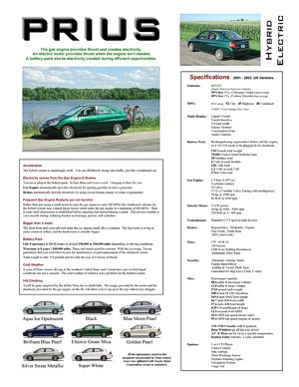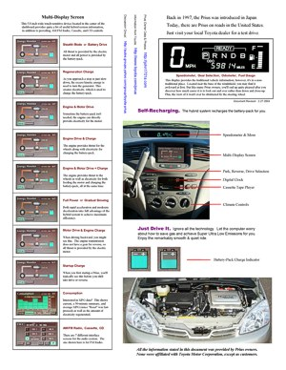
For an illustrated summary, refer to this document. It serves as a convenient means of introduction to all aspects of Prius.

Hhttp://john1701a.com/prius/prius-infosheet.htm

 | Energy Flow | 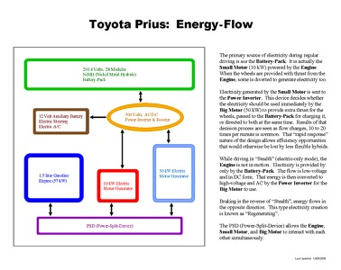 | For a basic understanding of the energy flow within the Prius hybrid system, download a copy of this document. Each of the major components are identified and the connection of each is explained in an easy to read format.  Hhttp://john1701a.com/prius/prius-energy.htm
 | Power-Split-Device | 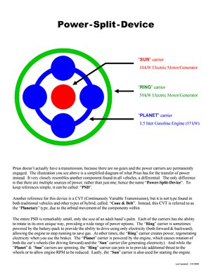 | For information about the heart of the hybrid system, read this document. This special device within Prius entirely eliminates the need for a traditional transmission. It is how the 2 electric motors and gasoline engine are able to seamlessly interact with each other.  Hhttp://john1701a.com/prius/prius-psd.htm
 | PSD (details) | 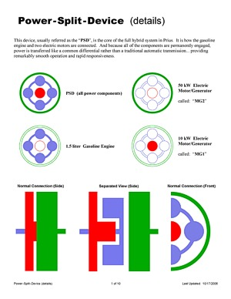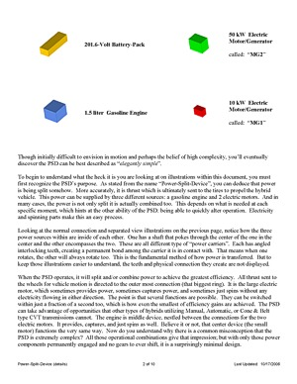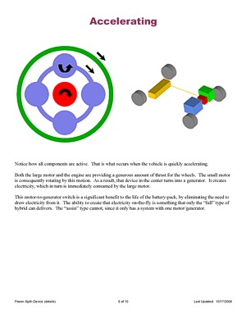
This document provides a more in-depth look at the PSD. Without being overly technical, the illustrations describe how the wide variety of movements within the device relate to the operation of the hybrid vehicle.

Hhttp://john1701a.com/prius/prius-psd_details.htmH

 | Understanding Hybrids | 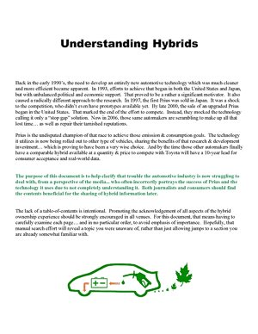 | The understanding of hybrids requires much more than just awareness of the efficiency values listed on the window-sticker and the fact that you don’t have to plug them in.  This document spells out the what you need to know.  Hhttp://john1701a.com/prius/prius-understanding.htm
 | Anti-Hybrid Analysis | 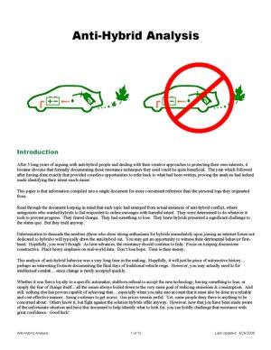 | Sadly, there are people that intentionally fight against hybrids, doing all they can to prevent their success.  Reading this will provide some insight. It is a summary of behaviors observed within online forums, based on several years of discussion messages posted about hybrids.  Hhttp://john1701a.com/prius/anti-hybrid_analysis.htm

 | Hybrid Types | 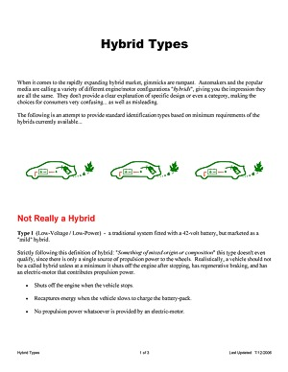 | There is a more diverse collection of hybrid system designs than most people realize.  This document helps by identifying and explaining the different types available.  Hhttp://john1701a.com/prius/hybrid-types_print.htm
 | Type: FULL | 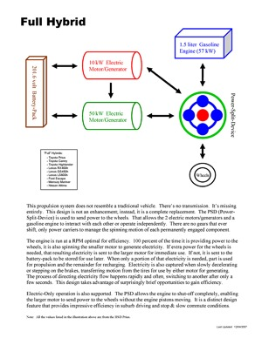 | The most dynamic of the hybrid types is known as "Full", since it includes a second electric motor to provide some abilities not available from lesser designs.  Prius is this type of hybrid.  Hhttp://john1701a.com/prius/hybrid-type_full.htm
 | FULL (details) | 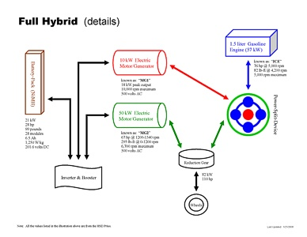 | For a more detailed illustration of the "Full" hybrid type, refer to this document.  Hhttp://john1701a.com/prius/hybrid-type_full_details.htm
 | Type: TWO-MODE | 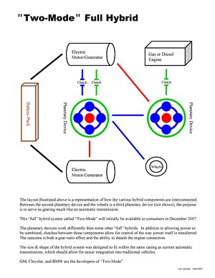 | This alternate variety of the "Full" hybrid is a configuration known as "Two-Mode". It adds another power-split-device for electric motor and engine interaction, plus multiple clutches.  This document highlights the differences you should be aware of.  Hhttp://john1701a.com/prius/hybrid-type_two-mode.htm
 | Type: ASSIST | 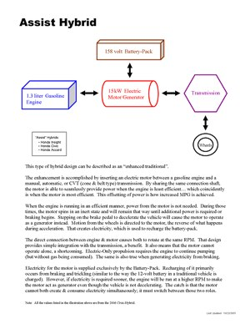 | The type of hybrid with only one electric motor that is directly integrated with an engine is known as "Assist".  There are benefits and limitations that those contemplating the purchase of this hybrid type should carefully consider.  Hhttp://john1701a.com/prius/hybrid-type_assist.htm
 | Type: SERIES | 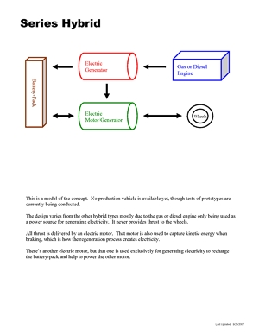 | A type of hybrid vehicle currently being concept tested. This document portrays the possible operational behavior it may deliver.  Hhttp://john1701a.com/prius/hybrid-type_series.htm
 | Misconceptions:  EFFICIENCY | 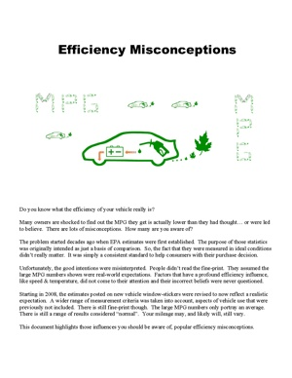 | Specific details about hybrid misconceptions related to efficiency of the system.  Hhttp://john1701a.com/prius/prius-misconceptions_efficiency.htm
 | Misconceptions:  HIGHWAY | 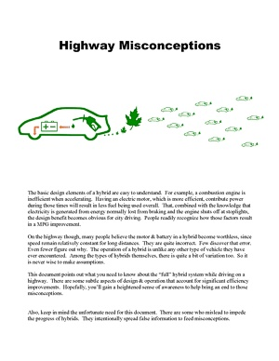 | Specific details about hybrid misconceptions related to operation while on the highway.  Hhttp://john1701a.com/prius/prius-misconceptions_highway.htm
 | Misconceptions:  WINTER | 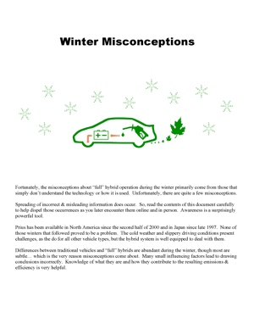 | Specific details about hybrid misconceptions related to conditions during the winter.  Hhttp://john1701a.com/prius/prius-misconceptions_winter.htm

 | FULL (operation) | 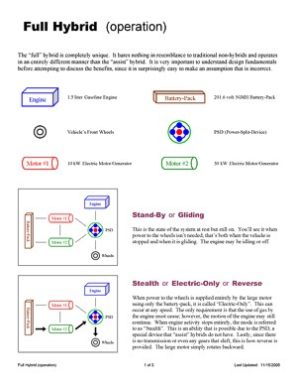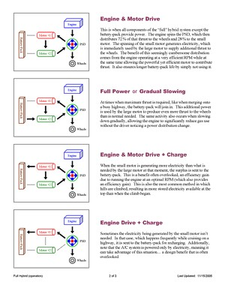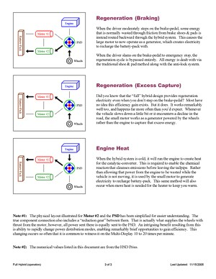
For an in-depth breakdown of how "Full" hybrids operate, download a copy of this document.

http://john1701a.com/prius/hybrid-type_full_operation.htm

 | Owner Summary | 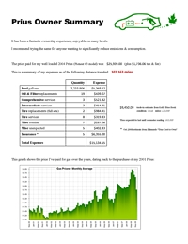 | Data from 5 years of Iconic Prius ownership summarized into charts & graphs.  http://john1701a.com/prius/prius-ownersummary.htm
 | Being Green | 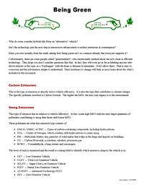 | Information you should be aware of when researching & discussing hybrids.  http://john1701a.com/prius/prius-beinggreen.htm
 | Requirements | 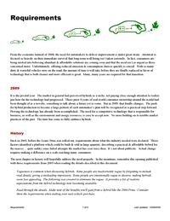 | Criteria that define genuine progress, the advancements required to significantly reduce emissions & consumption.  http://john1701a.com/prius/prius-requirements.htm

GLOSSARY

ABS | Anti-Lock Braking System, the feature which allows you to retain the ability to directionally control your vehicle during emergency deceleration.
AC | All modes of conditioning air inside the passenger area of the vehicle: Heating, Cooling, Venting
A/C | Condensing of air to cool it and to remove humidity.
Assist | Hybrid system with a small battery-pack and a single small electric-motor that provides peak power for the gasoline-engine during periods of acceleration.
AT-PZEV | Advanced Technology - Partial Zero Emission Vehicle
BAS | Belt-Alternator System – GM’s assist hybrid technology
"B" Mode | Engine Braking, (it isn't actually a gear) when you shift the transmission to this setting the engine will be used to slow down the car, it works similar to an exhaust brake used on the large semi-trucks (except the one on Prius is totally silent).
C | Celsius, a measure of temperature, (C * 1.8) + 32 = F, -25°C = -13°F, -15°C = 5°F, -5°C = 23°F,  0°C = 32°F, 5°C = 41°F, 20°C = 68°F, 25°C = 77°F, 30°C = 86°F
CAFE | Corporate Average Fuel Economy, the US system used to measure overall fleet efficiency
CARB | California Air Resources Board, an agency dictating emissions requirements for cars sold in California. (These are often more strict than Federal standards.)
CAT | Catalytic Converter, a vital component in the emissions system, typically utilizing a self-renewing metal
CC | Cruise Control
Cd | Coefficient of drag (0.29 for the Original & Classic Prius, 0.26 for the Iconic Prius)
CEL | Check Engine Light
Classic | The term used to identify the 2001 - 2003 model years of Prius.
CNG | Compressed Natural Gas
CO2 | Carbon-Dioxide, the type of vehicle emission that contributes to global warming.
CVT | Continuously Variable Transmission, Prius uses the "Planetary" design which functions as a power-split device to manage multiple sources of thrust; other CVT vehicles use a "Cone & Belt" design to adjusts power ratios.
Dinosaur | A very large, gas-guzzling, high-emission vehicle based on 20th century technology… doomed to extinction.
DRL | Daytime Running Lights
DVD | Digital Versatile Disc, used for the Navigational system in Prius
E10 | Blended engine fuel, 10% ethanol and 90% gasoline
E85 | Blended engine fuel, 85% ethanol and 15% gasoline
ECU | Electronics Control Unit, the amazing computer that monitors and controls the two motor-generators, the gas engine, the motion of the planetary gear set, the battery pack power levels etc. to provide the Prius' smooth acceleration and speed control.
Engine | The term used to refer to the device which runs on gasoline, utilizing combustion to push pistons to deliver power.
EPA | Environmental Protection Agency, the group responsible for rating the emissions & efficiency of vehicles sold in the United States.

EV | Electric Vehicle, powered exclusively by a battery-pack charged before use
F | Fahrenheit, a measure of temperature, (F - 32) / 1.8 = C, -15°F = -26.11°C, 0°F = -17.78°C, 15°F = -9.44°C, 32°F = 0°C, 40°F = 4.44°C, 60°F = 15.56°C, 70°F = 21.11°C, 80°F = 26.67°C
FCHV | Fuel Cell Hybrid Vehicle, a fuel-cell vehicle that takes advantage of hybrid technology including the use of a battery-pack
FOB | The device (introduced in 2003) used to unlock doors and start the hybrid system. By default, it works as a wireless remote for unlocking and is inserted into a slot in the dashboard for starting. As an option, it can be upgraded to control the SKS (formally known as SE/SS) feature. And note that there is actually a traditional key within which can be used for unlocking the driver's door manually.
FUD | Fear, Uncertainty, Doubt
Full | Hybrid system with a large battery-pack, a small electric-motor, at least one large electric-motor, and a gasoline-engine that combined provide a wide variety of combustion & electric propulsion abilities.
GPS | Global Positioning System, this is the part of the Prius Navigation System that identifies your exact location on Earth.
Greenwash | To intentionally mislead with respect to environmental benefits.
HEV | Hybrid Electric Vehicle
HID | High Intensity Discharge, bulbs used for headlights; illumination is created using an arch electricity instead of a traditional filament
HSD | Hybrid Synergy Drive - Toyota's modular hybrid design, implemented starting with the 2004 Prius with other vehicles now also using it.
HOV | High Occupancy Vehicle - used to describe the restricted "diamond" lanes on highways
HP | Horsepower, indicating a unit of power, a measurement different from torque
ICE | Internal Combustion Engine
Iconic | The term used to identify the 2004 - 2009 model years of Prius.
IMA | Integrated Motor Assist - Honda's hybrid technology
km | Kilometer, a measure of distance, 1 kilometer is equal to 0.6214 mile
kW | Kilowatt, an electrical measurement unit used when describing Prius power consumption & storage
LEV | Low Emission Vehicle, once the cleanest designation, but no surpassed by several levels of reduced emissions
L/100km | Liters per 100 kilometers, the more common unit of efficiency measurement outside of the US and UK
LMPG | Lifetime Miles Per Gallon
LRR | Low Rolling Resistant - used to describe minimum friction tires
MD | Multi-Display - the touch-sensitive liquid-crystal screen on the dashboard of Prius
Mi | Mile, a measure of distance, 1 mile = 1.6093 kilometers
MG | Motor Generator, an electric motor which can either provide motive power when electrically driven or generate electricity when mechanically driven.
MG1 | The smaller Prius electric motor. It is three-phase AC permanent-magnet synchronous motor/generator starts the ICE, controls the CVT, and generates the electricity (by using thrust from the ICE and deceleration power from slowing before the brake-pedal is pushed) to charge the battery-pack and/or feed the larger motor.
MG2 | The larger Prius electric motor. It is three-phase AC permanent-magnet synchronous motor/generator drives the wheels and generates electricity (from regenerative braking) to recharge the battery-pack.

Motor | The common term used to refer to the power device which operates using electricity.
MPG | Miles Per Gallon
MSRP | Manufacturer's Suggested Retail Price
MY2001 | Model Year 2001 (which became available in the United States the summer of 2000)
NAV | DVD-based GPS Navigation System, used in Prius
NiMH | Nickel-Metal Hydride, the type of modules used in the Prius battery-pack
NOx | Nitrogen Oxides, that type of vehicle emission that contributes to smog
NVH | Noise, Vibration, Harshness
OEM | Original Equipment Manufacturer, components directly from the automaker
OPEC | Organization of the Petroleum Exporting Countries
Original | The term used to identify the 1998 - 2000 model years of Prius (which were only available in Japan).
Priustoric | All that transpired before the Prius
PHEV | Plug-In Hybrid Electric Vehicle
PPM | Parts Per Million, the scale at which emissions are common measured, literally a count of matter within a unit
PSD | Power-Split Device, the planetary gear set which divides power between the ICE and the two electric motor-generators, also functions as the continuously-variable transmission.
PZEV | Partial Zero Emission Vehicle. (A manufacturer must eliminate evaporative emissions and ensure that the vehicle will run cleanly for its entire projected life. Even if the vehicle is just sitting in the driveway, it is still polluting. The source of this pollution is hydrocarbons emitted from the gas tank as gasoline slowly evaporates. To achieve PZEV certification, all evaporative emissions must be eliminated.)
R&D | Research & Development
SE | SKS: Smart-Entry. It is a proximity detection system that automatically senses a wireless transmitter (called a "fob") in your pocket or purse, allowing you to unlock the doors & hatch without the need to use a physical key or push a button on a remote.
SKS | Smart-Key-System (formally known as SE/SS: Smart-Entry & Smart-Start). It is the collective term used to describe all features of the wireless system available with some models of Prius.
SOC | State Of Charge, indicating the amount of stored electricity available in the battery-pack
SS | SKS: Smart-Start. It is proximity detection system that automatically senses a wireless transmitter (called a "fob") in your pocket or purse, allowing you to start the hybrid system without the need to use a physical key or push a button on a remote.
Stealth | Electric-Only driving (up to 42 MPH for Classic & Iconic Prius) without the engine in motion.
SRS | Supplemental Restraint System, better known as Airbags
SULEV | Super Ultra Low Emission Vehicle (only a few vehicles qualify for this clean rating category, Prius is among them)
THS | Toyota Hybrid System - Toyota's hybrid design for the Classic Prius
Torque | Measurement value indicating wheel turning force, a strength value different from horsepower
TRAC | Toyota Rent-A-Car, a program by which some have shortened the waiting time: when the demo/rental units reach a time/mileage it permits the dealer to sell them.

Turtle | Driving a Classic Prius with the battery-pack extremely drained of electricity, in conditions too hot (typically above 105 F degrees), or conditions too cold (typically below -10 F degrees), so that an orange "turtle" icon displays near the speedometer. This warns the driver to avoid forceful acceleration.
Two-Mode | GM’s full hybrid technology
ULEV | Ultra Low Emission Vehicle (as of the 2003 model-year there were 90 vehicle models in the United States that met the rating criteria)
V | Volt or Voltage, an electrical measurement unit used when describing attributes of Prius propulsion components.
VIN | Vehicle Identification Number, the worldwide identifier unique to each vehicle ever built
Vaporware | A term from the computer industry used to describe claims made by a company about a product that was never delivered. It sounded great in concept, but for whatever reason was impractical in the end. In other words, don't believe it until you actually see the product available for consumers to purchase.
VSC | Vehicle Stability Control, a safety feature that automatically engages side-specific braking for you when it detects the vehicle wheels slip; stepping on the brake is not necessary for the feature to work
ZEV | Zero Emission Vehicle

Prius Generations:
 | Original | Classic | Iconic | 2010
Engine HP  Engine kW  Engine RPM  Motor/Generator 2 HP  Motor/Generator 2 kW  Motor/Generator 2 Torque  Motor/Generator 2 RPM  Motor/Generator 1 kW (rated)  Motor/Generator 1 RPM  0-60 MPH (seconds)  Tire Width  Tire Diameter  Battery-Pack Energy (W/kg)  Battery-Pack Voltage  Battery-Pack Weight (lbs)  Battery-Pack Section (type)  Battery-Pack Section (count)  Hybrid-System HP  Hybrid-System kW  Hybrid-System Voltage | 58  43  4000  40  30  225  2000  15  4800  14.1  165  15  600  288  125  D-Cell  40  101  64  288 | 70  52  4500  44  33  258  5600  15  6500  12.5  175  14  900  273.6  110  Module  38  98  73  273.6 | 76  57  5000  67  50  295  6700  30  10000  10.1  185  15  1250  201.6  99  Module  28  110  82  500 | 98  73  5200  80  60  153  13500  42  10000  9.8  195  15  1250  201.6  110  Module  28  134  100  650

