Home

Household electricity is limited to volts & amps much lower than what DCFC (DC Fast Charger) has to offer. Charging from a standard AC (120 volts) output will deliver about 5 miles per hour. Charging output varies from high-power AC (240 volts) connections, but in general deliver about 25 miles per hour.
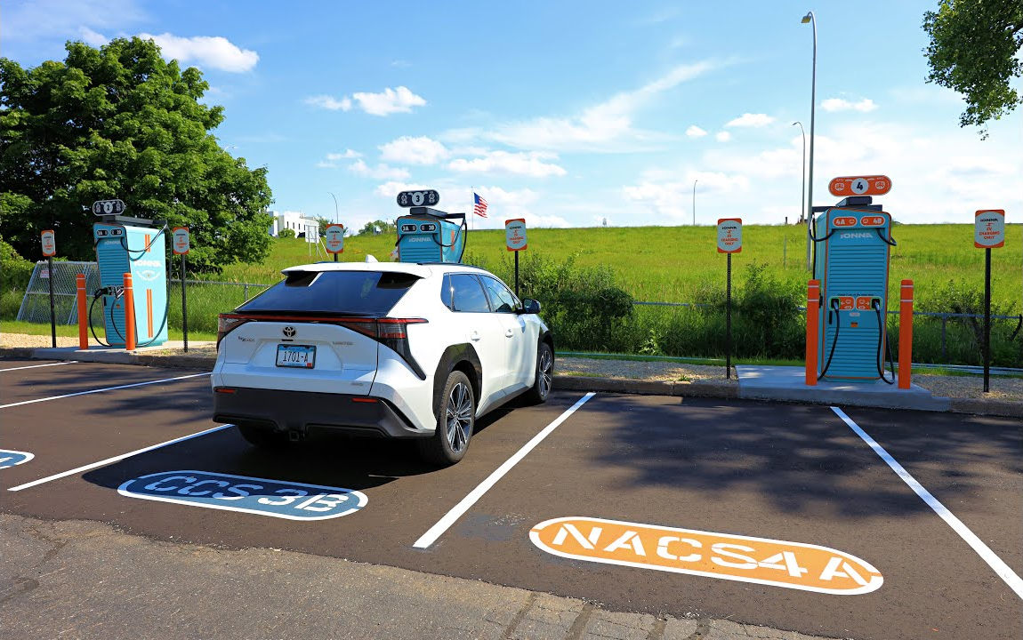 |  | Travel  Fast charging DC (480 volts) stations are available for EV owners who need much more speed than available at home. The charging rate itself varies based on a wide variety of factors, such as temperature and station output. Ideally, an EV's battery can be charged from 10% to 80% capacity in about 30 minutes.  Cost  Price is based upon kWh (Kilowatt Hour) quantity the EV receives while charging. There may also be a connection fee. For roughly 150 miles of range, you would need approximately 45 kWh of electricity. At an average of $0.55 per kWh (much more expensive than home charging), that would be $24.75.
 | 
Precondition  Some EVs provide a feature to "precondition" the battery in preparation for faster DC charging, prior to plugging in. Temperature target is 95°F to 122°F (that's 35°C to 50°C). Taking advantage of it saves time, but reduces available range by consuming the battery's electricity.  Charge Curve  Charging will be faster the lower SOC (State Of Charge) is for the battery. As SOC increases while charging, the speed will slow at an increasing scale. Illustrated on a graph, that is represented as a curve. This is why DC charging works best when the EV has very little range remaining. |  |  | 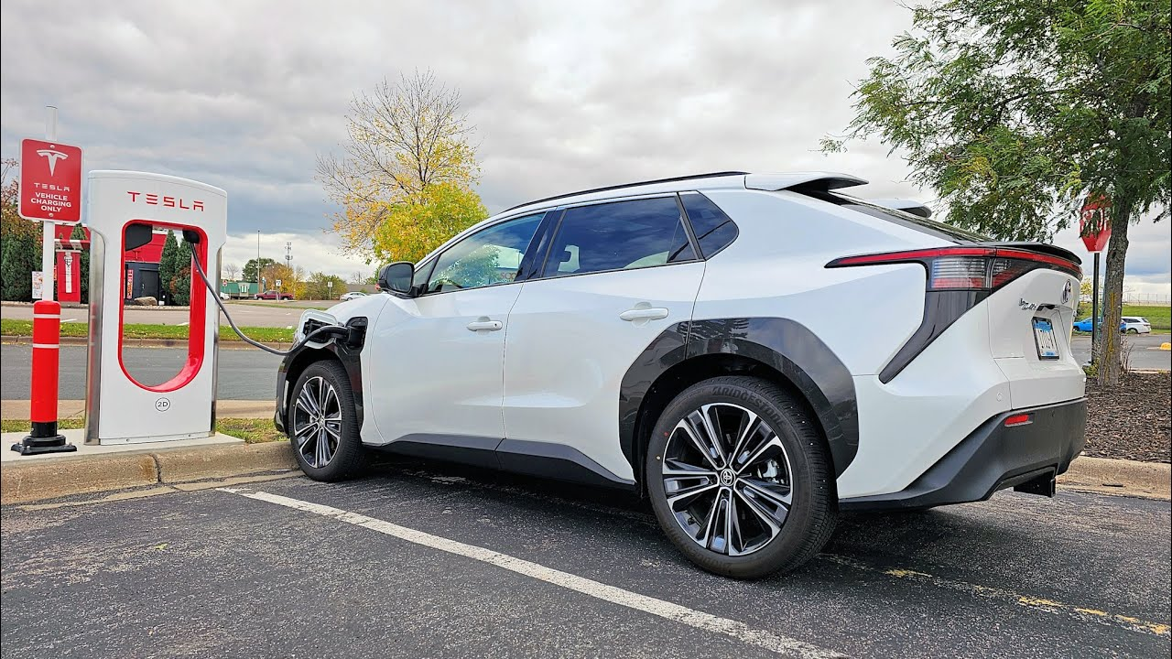
 |  |  | 
Plug Type

2026 model EVs bring about a standard, eliminating bulky combinations of the past. This plug type is known as NACS (North American Charging System). Automakers are providing adapters for both old and new EVs. So, there should be no concern about compatibility during the transition.

