Phone Apps
A wide variety of apps are available for helping you find chargers, in addition to your vehicle’s navigation system and Google.  Each provides a means of searching & filtering. In addition to pricing information, some include current availability status at each location.  If the station itself does not provide a credit-card reader, the app can also be used for starting a session & payment. | 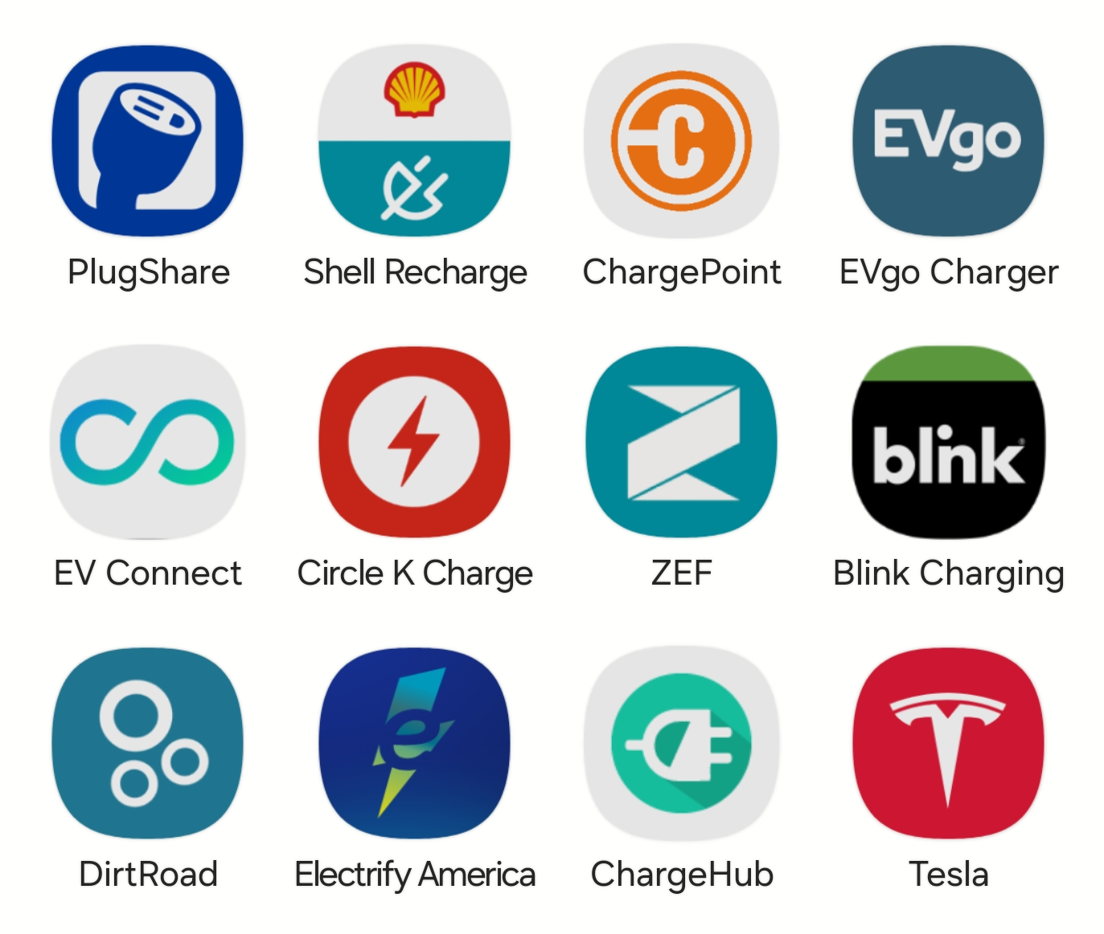
Charger Types
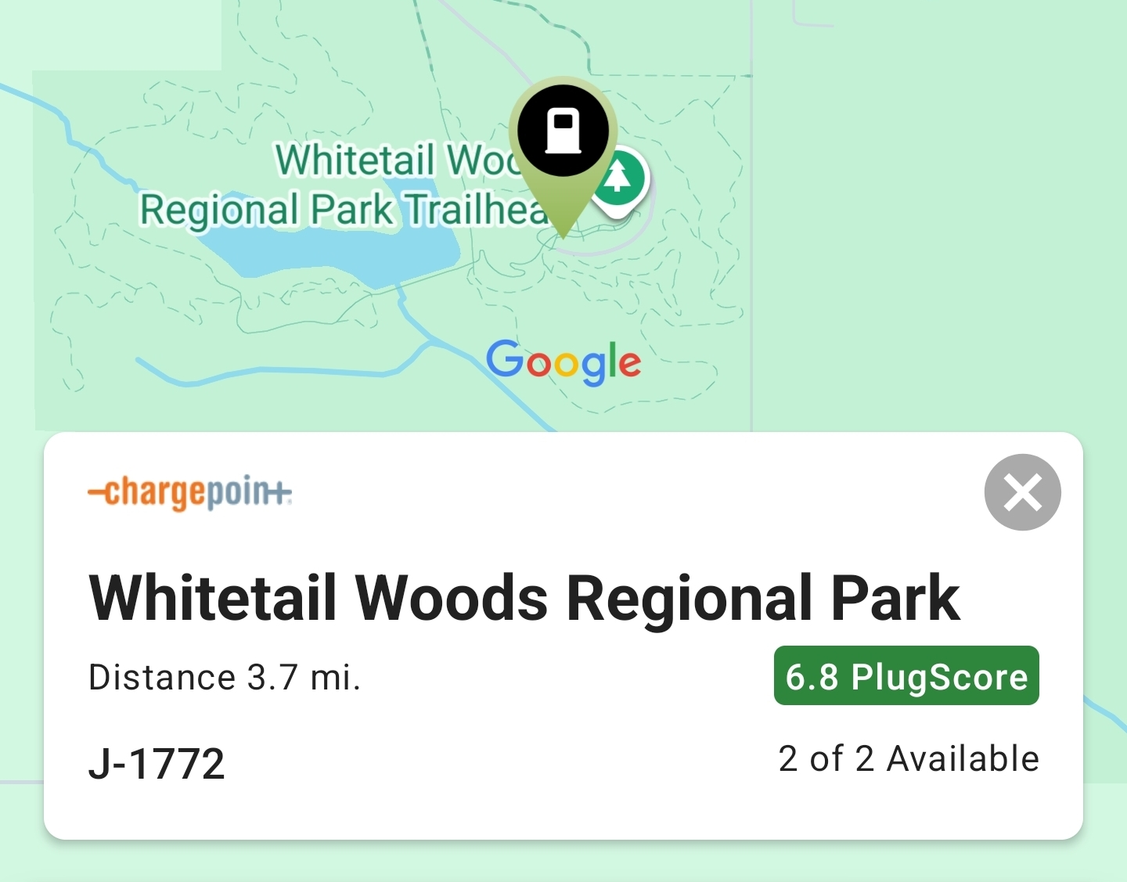 | Since charging time is directly related to charger type, search tools are vital.  Whether you’re looking for fast DC chargers (CCS1 & NACS) or just slow AC chargers (J-1772), both are easy to search for.  These examples provided by “PlugShare” show availability information and review scores. | 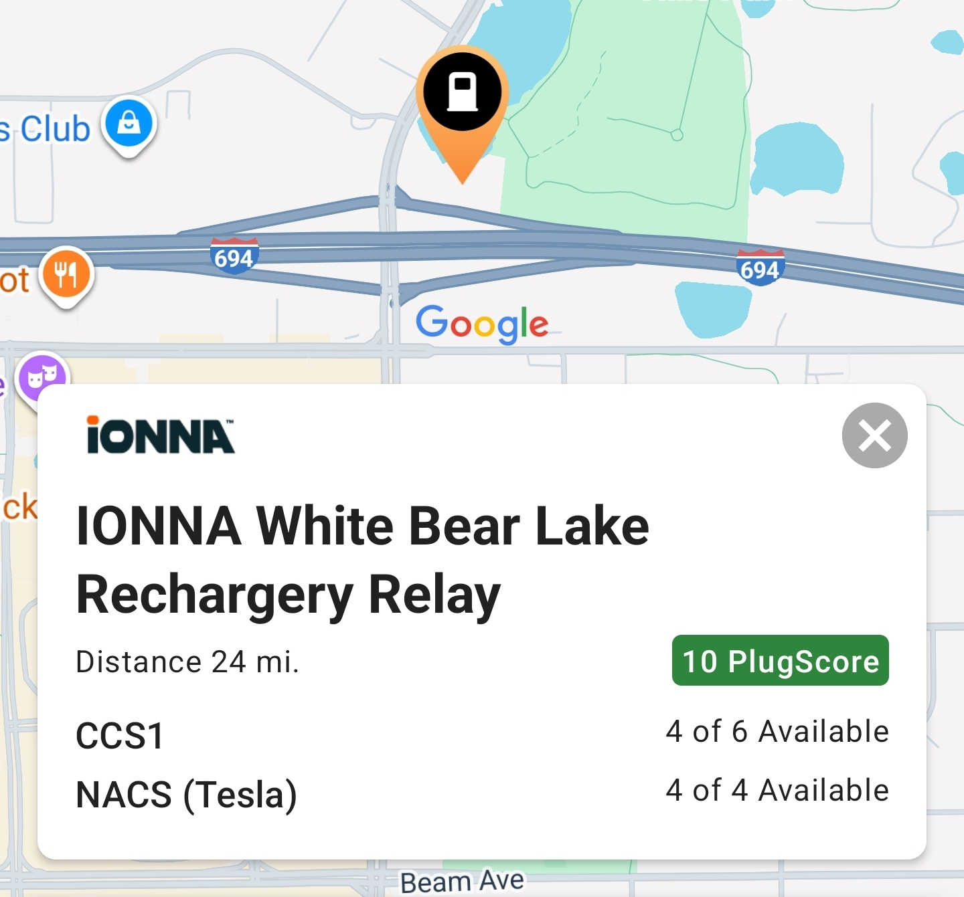
Route Planning
Many phone apps and websites provide the ability to plan a drive route. You can specify battery-level from trip start to destination with flexibility to change suggested charging locations. For example, using ABRP (A Better Routeplanner), it determines charging times & duration for your trip.
