Range  Winter demands of cabin & battery warming, plus longer drive times due to slower traffic, will reduce the number of miles available. That range reduction will be up to 35% when outside temperature is well below freezing. Warming the vehicle prior to unplugging is helpful.  Efficiency  Impact of cold temperatures can easily be observed by watching electricity consumption. That value is depicted by mi/kWh (Miles per Kilowatt Hour). Lower indicates greater winter impact. It will return to being higher when spring arrives. |  |  | 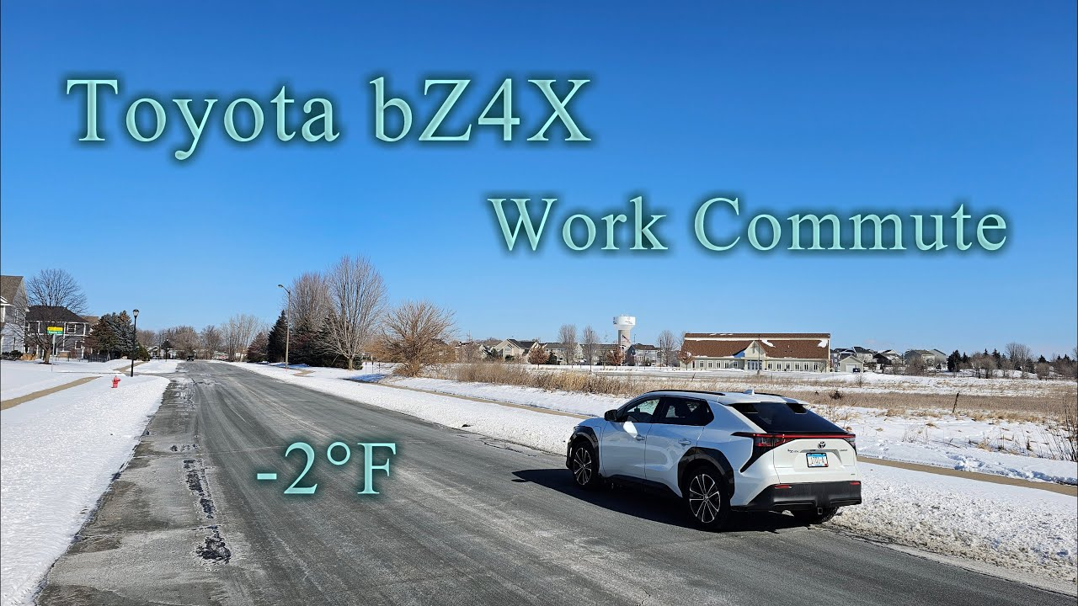
 |  |  |  | 
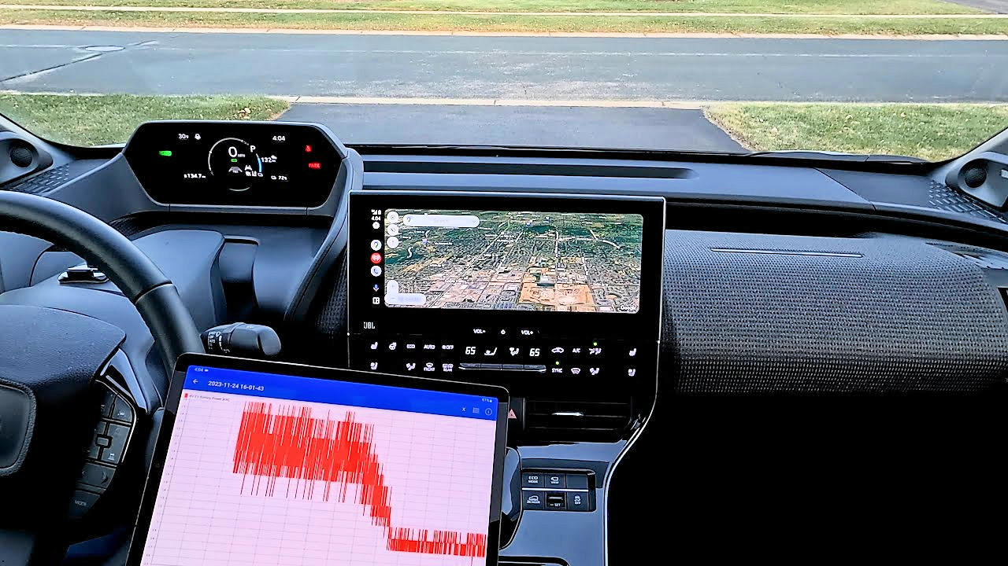 |  | Cabin Warming  Take advantage of heated seats to offset electricity consumption for warming the cabin (passenger) area. That will help retain range, since some EVs use a less efficient resistance-heater rather than a heat-pump.  Battery Temperature  Electrical resistance increases significantly when temperature of the battery itself is below freezing, resulting in reduced range. Setting the battery-heater to warm while plugged in will minimize winter impact.

Fast Charging  Some EVs provide a feature to "precondition" the battery in preparation for faster DC charging, prior to plugging in. Taking advantage of it saves time. Temperature target is 95°F to 122°F (that's 35°C to 50°C).  Snow & Ice  Due to the heavier weight and lower center-of-gravity from the battery, EVs typically maintain traction and handle very well in winter driving conditions. |  |  | 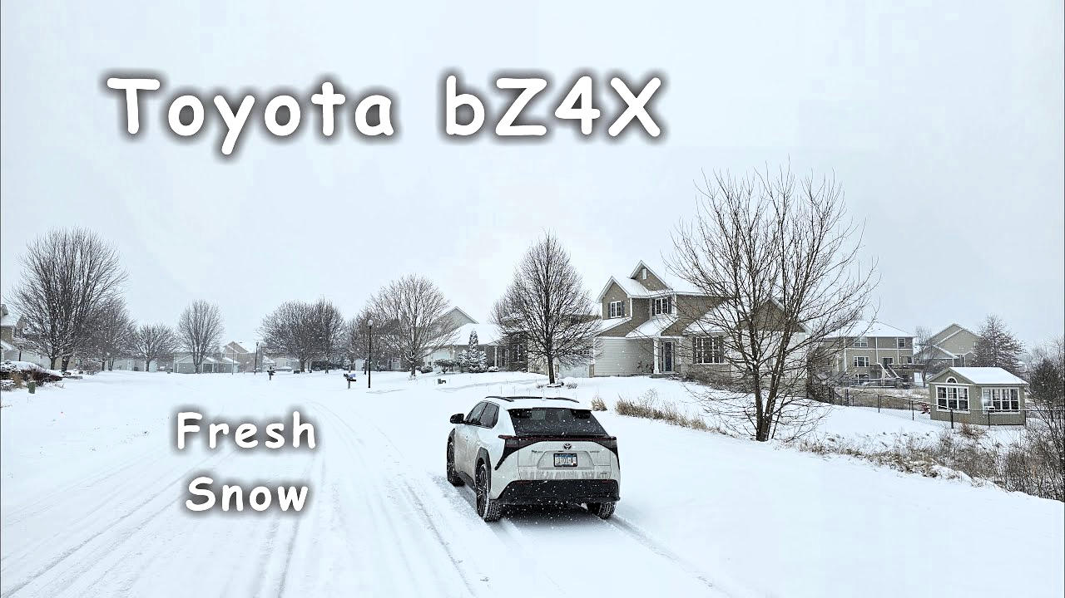
 |  |  | 

